**SEO_MART Database Structure**

**Encounter Attendance & Provider Assignment:**

**RS, PS, Para Services**

**BRD- Draft**

(Internal)

Table of Contents

1 Project Summary 3

1.1 Project Statement 3

2 Introduction 3

2.1 Overview 3

2.2 High Level Process 3

2.3 Scope 4

2.4 Column Requirements 6

2.5 Stakeholders 8

3 Assumptions, Dependencies & Constraints 9

3.1 Assumptions 9

3.2 Dependencies 9

3.3 Constraints 9

4 Important Links and Documents 10

4.1 Introduction 10

4.2 Functional Requirements 10

5 Document Control 11

5.1 Revision History 11

5.2 Reviewers (to date) 11

# Project Summary

## Project Statement

The purpose of the SEO_MART database redevelopment project is to develop a transparent, flexible and streamlined reporting environment to support the SEO Reporting and Analytics team in reporting and analyzing data involving students with disabilities.

This document outlines the processes and rules used to develop the **Encounter Attendance and Provider Assignment** reporting tables on SEO_MART. These tables identify Related Services, Paraprofessional, and SETSS mandates on the IEPs of active students in SESIS and connect those mandates to “encounters” (certified interactions between students and service providers) in the encounter attendance module or “first attends” in the provider assignment module in order to measure the provision of those services.

# Introduction

**Encounter Attendance (EA)**

* Encounters are stored in the **Encounter Attendance Module**. In our processing, we use all encounters for active students with a service date that occurs after September 1st of the current school year. This includes encounters for Relates Services (RS), Special Education Teacher Support Services (SETSS), and Paraprofessional Services.
* When calculating actual encounters, only services that have been provided and certified (used to bill the state for the services) by the provider are counted. Makeup or canceled services are not considered certified and therefore do not count as actual encounters. However, they are reflected in our underlying systems.
* We currently use the **First Attend Date** to quantify the provisioning of mandates in EA. **This is the earliest date in a school year when the Match Key associated with a mandate in SESIS matches a corresponding Match Key** for a certified encounter in EA.
* For example, for a Related Service Mandate, the MatchKey in EA consists of Language of Instruction, Type of Service, Group Size, and StudentID.

**Provider Assignment (PA)**

* **Provider Assignment** is a tool for only external providers that assigns external providers to mandated student services. In our processing, we use assignments for **active students with mandates that were created on or after August 1st of the current school year.**
* We use **PA First Attend Date** to quantify the provisioning of mandates in PA. This is the date when the provider first accepts to support the students with the services needed. That is, the PA first attend date is the earliest date when the **Match Key** associated with a mandate in SESIS matches a corresponding **Match Key** in PA.
* For example, for a Related Service Mandate, the **MatchKey** in PA consists of Language of Instruction, Type of Service, Group Size, StudentID, as well as **Recommended Service Duration**.

## Overview

**The following are distinct service types**

|  |  |
| --- | --- |
| **Service Type Name**  **\*green indicates services being reviewed** | **Notes** |
| Audiology Services |  |
| Counseling by a Social Worker / Psychologist |  |
| Counseling Services | **Big 6** |
| Hearing Education Services | **Big 6** |
| Interpreting Services - Oral Transliterator |  |
| Interpreting Services - Sign Language Interpreter |  |
| Medical Services |  |
| Occupational Therapy | **Big 6** |
| Orientation and Mobility Services |  |
| Other |  |
| Parent Counseling and Training |  |
| Physical Therapy | **Big 6** |
| Psychological Services |  |
| School Health Services |  |
| School Nurse Services |  |
| School Social Work |  |
| Speech-Language Therapy | **Big 6** |
| Vision Education Services | **Big 6** |
| Assistive Technology |  |

DWH_EncounterAttendance:

Below business rules are used to identify the IsValidService flag:

|  |  |  |  |  |  |  |  |
| --- | --- | --- | --- | --- | --- | --- | --- |
| **Certified** | **IsDelete** | **ServiceLocationDesc not to be included** | **CompensatoryCB** | **Service** | **Use the following column** | **Codes not to be included** | **Expected IsValidService** |
| 1 | 0 | Consultation,Phone only consultation, Tele-therapy consultation | 0 | SETSS | SETTSCompSessionType | 5,6,7,10,11,12,13,14,15 | 1 |
| All other services | CompSessionType | 5,6,7,10,11,12,13,14,15 | 1 |
| 1 | 0 | Consultation,Phone only consultation, Tele-therapy consultation | 1 | SETSS | SessiontypeID | 5,6,7,10,11,12,13,14,15 | 1 |
| All other services | NotSETTSSessionType | 5,6,7,10,11,12,13,14,15 | 1 |
| 1 | 0 | Consultation,Phone only consultation, Tele-therapy consultation | NULL | SETSS | SessiontypeID | 5,6,7,10,11,12,13,14,15 | 1 |
| All other services | NotSETTSSessionType | 5,6,7,10,11,12,13,14,15 | 1 |

EA/PA MatchKey

* As mentioned in the Overview section of the EA/PA BRD, the **MatchKey allows users to identify the First Attend Date**. To support our various EA/PA related reports, the MatchKey is tailored to the needs of the reports indicated in the chart below. As such, **there are multiple MatchKeys to meet the specific needs of our various work areas**.
* In order to reflect what is recommended in a student’s mandate, various proposals of expanding the MatchKey requirements is being considered. Including Duration and Location into a MatchKey is tricky as these can fluctuate throughout the week. Analysis for ongoing provisioning supports thinking about under, over and not serviced students.
* Para encounters are currently being reported in the underlying data of the Related Services dashboard. **Para encounters included in the backend data is created the same way as the Related Services encounters (First Attend/First Encounter).** However, Para duration is a different concept than Related Services as duration is how much a full time employee is dedicated to that student. Further, there is no concept of frequency with Paras as they are daily. Therefore, MatchKey for Paras is like Related Services but currently does not match up to the Para mandates. **In order to better align with the para mandate, the Para duration (1, .8, .2) should be considered in the MatchKey.**
* **Other supplementary aids are largely free text recommendations** making specific MatchKey for these services very challenging
* Matching service type to the mandate is difficult for **Assistive Technology as there are lots of free texts and no way to understand the encounters for that particular mandate**. The group versus individual identifier poses challenges, as many of our students do not have these recommendations attached to their mandates.
* SETSS is currently not in our INT table layer. **Because we do not have subjects, it is difficult to match to the student’s mandate**. Provider’s special education license will need to be reflected in our MatchKey to indicate certified SETSS services. Therefore, the provider employee id is necessary in our INT layer. For our future City Council reports, we will have to break down by student’s service type. By including locations to our SETSS MatchKey criteria will support our non encountered students into a partial encounter bucket. However, there is no way to match to Full encounters with this location criteria. The goal, however, for SETSS only kids who are having encounters should be to see some sort of encounters in our reports.

|  |  |  |  |
| --- | --- | --- | --- |
| Area of Work | MatchKey Needed | Descriptions and Purpose | Amount of Data needed |
| Related Services Reporting | Studentid + Service +Groupsize +Language  Studentid + Service+Groupsize | Identify full and partial first encounter (the language provided does not match)  (current rules) | Student is not in a Twelve Month Program  Student is active in SESIS Student is in CSD or Charter school Student is not PRE K |
| Assistive Technology Services | Studentid + Service | Identify first encounter for AT | Only active services (is this correct) |
| SETSS Services | Studentid + Service + Language + Location(?)  We need ProviderID to understand if they are special educators  Would language matter here? | Identify first encounter for SETSS program services | Only active services (is this correct) |
| Ongoing Provisioning | Studentid +Service +Groupsize + Language +Location  Studentid + Service +Groupsize +Language  Studentid + Service + Groupsize | For analysis, use current logic of full and partial encounter.    Create much stricter matching logic that looks at location | SY 18-19 SY19-20 (up until March 1st, 2020)  Need All services from IEP, even if the services goes inactive within the year  Currently looking at Total full encounter (25% match-with location and duration), Partially, Not Receiving. Analyzing who was fully linked to all matchkey and slowly removing different matchkey requirements. Kisha is currently looking into partial encounters (currently Jose P encounters are only full encounters). |
| Paraprofessional Services | Studentid + Service +Groupsize +Language  Studentid + Service+Groupsize  **Start/End Dates, GroupType, ServiceDuration**  *Some IESP para mandates have no matchkey (e.g. 204583702). This seems to be tied to the concept of a Physical Assistance para, which is not found on IEPs. | Identify full and partial first encounter (the language provided does not match) | Student is active SESIS with Para service Student is in  CSD or Charter school Student is not PRE K |

**Group Size and Actual Group Size on SESIS**

**Actual Group Size** helps us understand the number of students in a Group service and group service absences as it **reflects the exact number of students present in the session**. This does not reflect the mandated group size.

However, ENL groups are allowed up to 12 students per session but SESIS limits groups by 8. The Actual Group Size will only reflect 8 but the Actual size of the group for more than 8 should be reflected in the Session Notes.

All NULLS indicated in this column refers to an individual session where the provider did not fill out the Actual Group Size on SESIS. Similarly, we may also see ActualGroupSize of 1 and GroupSizeDesc as Individual because the provider filled out the Actual Group Size on SESIS.

Most up to date visios can be found in the Related Services Sharepoint Folder:

<https://nycdoe.sharepoint.com/sites/SEODMReportingTeam/Shared%20Documents/Forms/AllItems.aspx?viewid=a03b1e09%2D3c9b%2D4fa5%2Db4d2%2De6b07dd59d05&id=%2Fsites%2FSEODMReportingTeam%2FShared%20Documents%2FTechnical%20Documentation%2FRelated%20Services>

|  |  |  |
| --- | --- | --- |
| DWH | INT | RPT |
| DWH_  Related ServicesRAD | INT_RSRADProfiles | RPT_  SESISActiveIEP |
| DWH_  RSRADProfiles | INT_  EncounterAttendance | RPT_  StudentRegister |
| DWH_  EncounterAttendance | INT_  ProviderAssignment | RPT_  Locations |
| DWH_  ProviderAssignment | INT_  RelatedServices |  |
| DWH_  Related Services | INT_  EncounterAttendanceLinkage |  |
| DWH_  Outcomes | INT_  ProviderAssignmentLinkage |  |

[Related Services Linkage](https://nycdoe.sharepoint.com/:u:/r/sites/SEODMReportingTeam/_layouts/15/Doc.aspx?sourcedoc=%7B0CE8CE35-B04A-4E1E-A5B5-E68B0D115CF9%7D&file=RelatedServicesLinkage%20Data%20Flow%20Diagram%20-%20SEO_MART%202.0%20RAD.vsdx&action=default&mobileredirect=true)

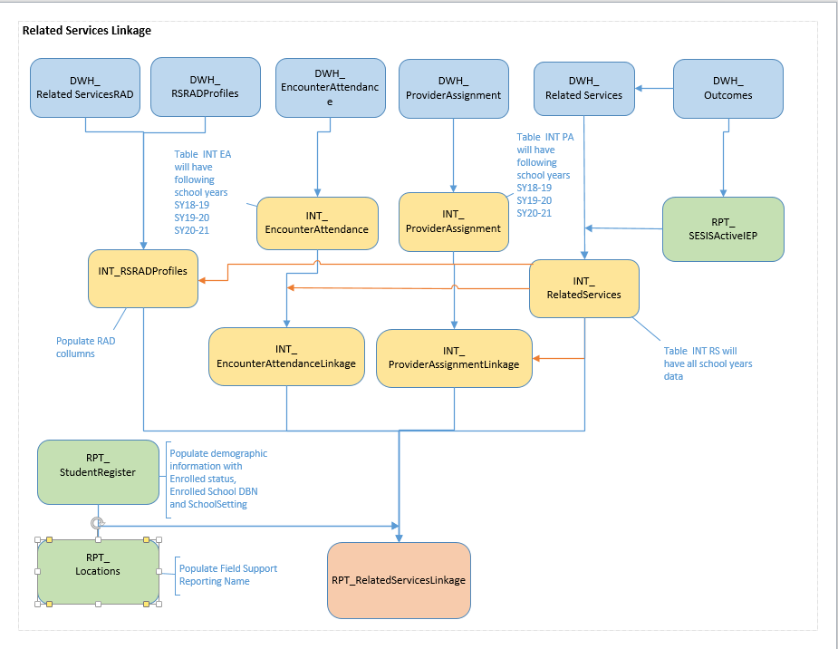

[Para Services Linkage](https://nycdoe.sharepoint.com/:u:/r/sites/SEODMReportingTeam/_layouts/15/Doc.aspx?sourcedoc=%7B3FCB0E7F-F721-47FE-8398-C527410274FE%7D&file=Paraprofessional%20Services%20Linkage%20Data%20Flow%20Diagram%20-%20SEO_MART%202.0.vsdx&action=default&mobileredirect=true)

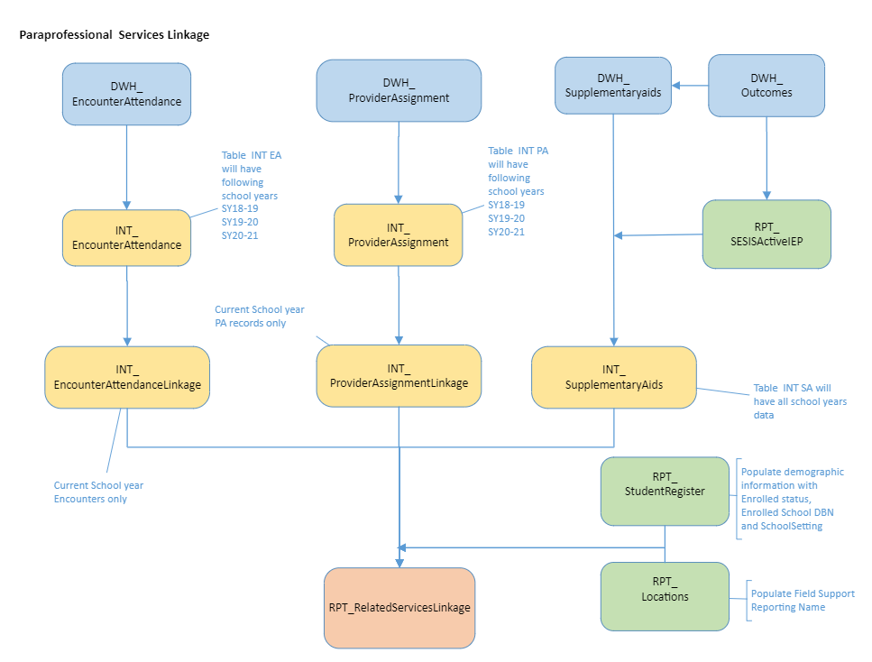

[RS Provisioning and Compliance](https://nycdoe.sharepoint.com/:u:/r/sites/SEODMReportingTeam/_layouts/15/Doc.aspx?sourcedoc=%7B0D2FB794-11CB-44A8-87CD-C6CC6B9ED55E%7D&file=Related%20Services%20Provisioning%20and%20Compliance%20Data%20Flow%20Diagram-SEO_MART%202.0.vsdx&action=default&mobileredirect=true)

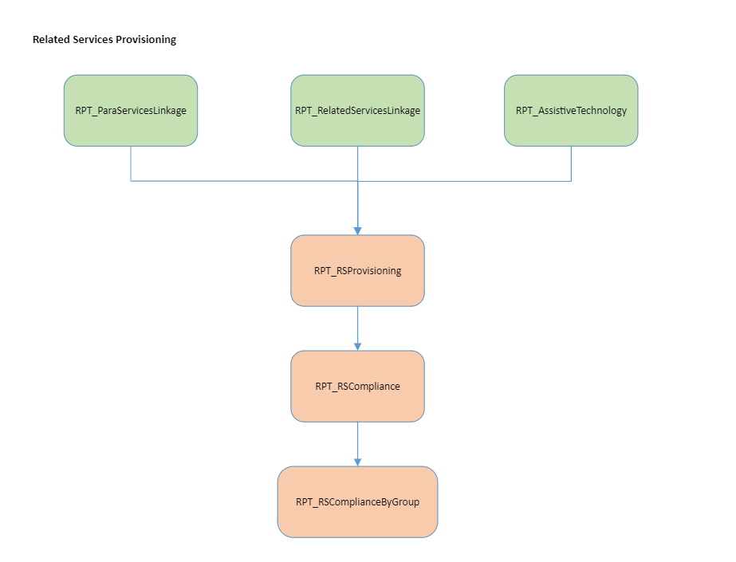

[RS Dashboard:](https://nycdoe.sharepoint.com/:u:/r/sites/SEODMReportingTeam/_layouts/15/Doc.aspx?sourcedoc=%7B99FEA9FB-50EF-4BC8-A137-707290FD7C3D%7D&file=Related%20Services%20Dashboard%20Data%20Flow%20Diagram%20-%20SEO_MART%202.0.vsdx&action=default&mobileredirect=true)

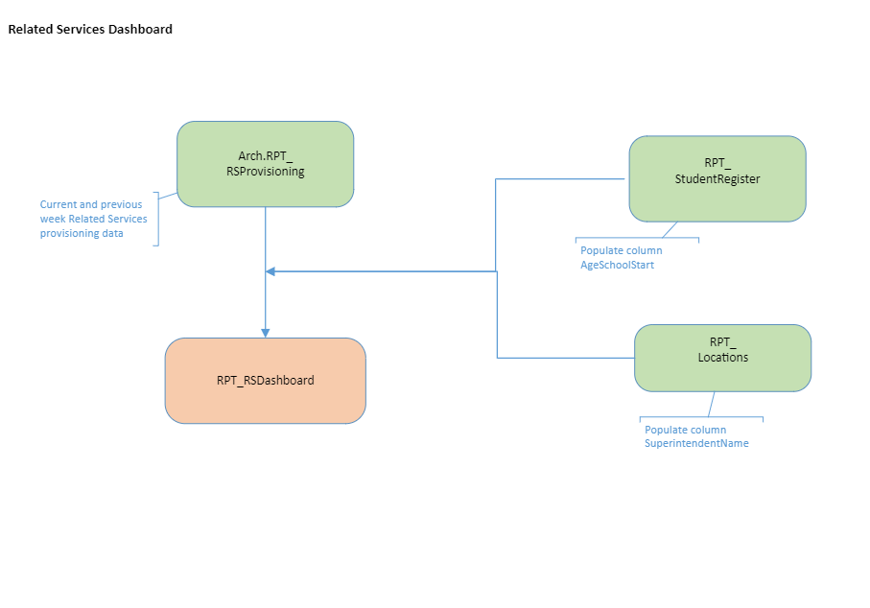

[RPT_RelatedServicesSummer](https://nycdoe.sharepoint.com/:u:/r/sites/SEODMReportingTeam/_layouts/15/Doc.aspx?sourcedoc=%7BCB960BAB-6940-4765-8272-89C249B84454%7D&file=Summer%20Related%20Services%20Data%20Flow%20Diagram%20-%20SEO_MART%202.0.vsdx&action=default&mobileredirect=true)

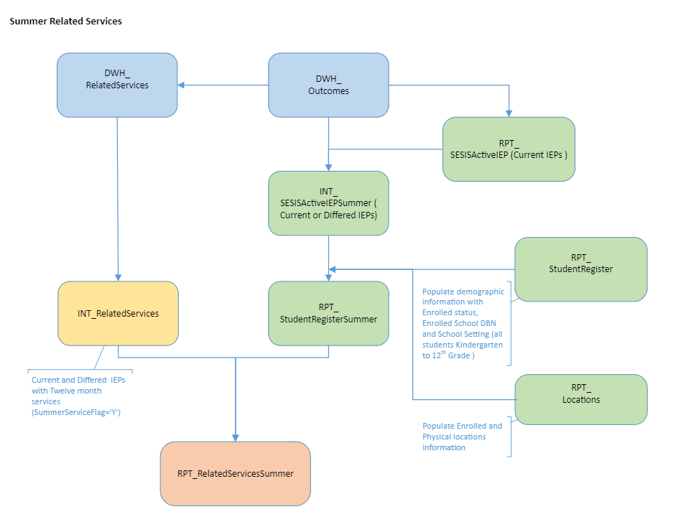

[RPT_ParaServicesSummer](https://nycdoe.sharepoint.com/:u:/r/sites/SEODMReportingTeam/_layouts/15/Doc.aspx?sourcedoc=%7BE5A0BB1B-9939-4146-88E7-2691934B1CDD%7D&file=Summer%20Paraprofessional%20Services%20Data%20Flow%20Diagram%20-%20SEO_MART%202.0.vsdx&action=default&mobileredirect=true)

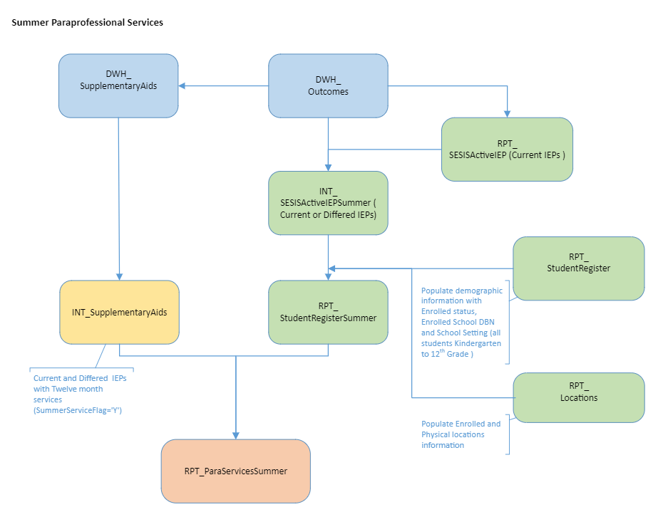

## Reports Delivered

Guideline on generating reports will be under 4.2 Functional Requirements

|  |  |  |
| --- | --- | --- |
| * Reports/Process – Deliverables | * Lead | * How is it Shared? |
| * Principal and RS Point Distribution List | * Andrea | * Cognos Email * Combined with Principals from Locations table * R:\SEO Analytics\Processing\Data Mart Files\RS_Point_Person |
| * Weekly Related Services Reports – School Level Files | * Andrea | * Shared for DIIT here:   R:\All Central Offices\Special Ed Data\PA_Distribution_PDF  R:\All Central Offices\Special Ed Data\PA_Distribution_XLS   * -Related Services Folder on SEO_MART * R:\All Central Offices\Special Ed Data\PA SharePoint – For MVB and DIIT * -R:\SEO Analytics\Processing\Data Mart Files\RS_Point_Person\Archives |
| * Weekly Related Services Report rollups by: * FSC à BCO * Superintendent * Supervisors * All | * Andrea | * Updates at the Borough/City wide office (BCO) level have been updated to R:\Drive (R:\All Central Offices\Special Ed Data\PA SharePoint) and posted to [SharePoint.](https://nam10.safelinks.protection.outlook.com/?url=https%3A%2F%2Fnycdoe.sharepoint.com%2F%3Af%3A%2Fr%2Fsites%2Fseo%2FShared%2520Documents%2FMandated%2520Services%2520updates%3Fcsf%3D1%26web%3D1%26e%3DD2JRDb&data=04%7C01%7CAKim14%40schools.nyc.gov%7Cda2956c8426a41554b9108d91eeaeddc%7C18492cb7ef45456185710c42e5f7ac07%7C0%7C0%7C637574816628440711%7CUnknown%7CTWFpbGZsb3d8eyJWIjoiMC4wLjAwMDAiLCJQIjoiV2luMzIiLCJBTiI6Ik1haWwiLCJXVCI6Mn0%3D%7C1000&sdata=X0%2BNlxXKidy20Z6U7soXkfAdhTRIb5F18sHdGaRS2Ao%3D&reserved=0) |
| * RS Dashboards | Andrea | <https://nycdoe.sharepoint.com/sites/RelatedServicesDashboard> |
| * Weekly Communication Emails | * Andrea | * MVB provides updated point list to our team, which we use to create our weekly distribution list for our weekly communication to DIIT on Mondays |

## Scope

This section clarifies the scope of the requirements with reference to the scope of the overall project

Team 2 Design Sprint Related Services/Para table name description proposals:

|  |  |  |
| --- | --- | --- |
| **TableName** | Description of Table | Business Rules |
| DWH_EncounterAttendance | Source table with encounter data from Encounter Attendance Module in SESIS |  |
| DWH_ProviderAssignment | Source table with provider data from Provider Assignment Module in SESIS |  |
| DWH_RelatedServices | Source table with related services mandates from SESIS |  |
| INT_RelatedServices | Intermediate table containing all active and historical cleaned services from DWH_RelatedServices for all settings | Not Deleted RS records 10 Month Recommendations (IsTwelveMonthProgram) |
| INT_ActiveRelatedServices_053119 | Snapshot from 05/31/2019 of intermediate table containing active related services mandates for students who are active in SESIS. |  |
| INT_EncounterAttendance | Intermediate table with encounter data for two years of data (SY18-19, SY19-20, SY20-21) |  |
| INT_EncounterAttendance_053119 | Snapshot from 05/31/2019 of intermediate table with encounter data only for the current school year |  |
| INT_ProviderAssignment | Intermediate table with provider data only for two years of data (SY18-19, SY19-20, SY20-21) |  |
| INT_ProviderAssignment_053119 | Snapshot from 05/31/2019 of intermediate table with provider data only for the current school year |  |
| INT_SupplementaryAids | Intermediate table containing all active and historical cleaned services from DWH_ SupplementaryAids for all settings |  |
| RPT_ParaServicesLinkage | Reporting table that links active paraprofessional mandates from INT_SupplementaryAids with provider and encounter data | ActiveServiceFlag= ’Y’  ActiveDocumentFlag= ’Y’  Not Deleted RS records 10 Month Recommendations (IsTwelveMonthProgram) |
| RPT_ParaServicesLinkage_053119 | Snapshot from 05/31/2019 of reporting table that links active paraprofessional mandates with provider and encounter data |  |
| RPT_RelatedServicesLinkage | Reporting table that links active related services mandates from INT_RelatedServices table with provider and encounter data for all school settings | ActiveServiceFlag= ’Y’  ActiveDocumentFlag= ’Y’ |
| RPT_RelatedServicesLinkage_053119 | Snapshot from 05/31/2019 of reporting table that links active related services mandates with provider and encounter data |  |
| RPT_RSCompliance | School level roll up of RPT_RSProvisioning used in RS Compliance Report |  |
| RPT_RSCompliancebyGroup | FSC and and Superintendent level roll ups of RPT_RSProvisioning used in RS Compliance Report |  |
| RPT_RSProvisioning | Reporting table which holds student's related services mandate, encounter information and paraprofessional data |  |
| RPT_RSProvisioning_053119 | SY19 snapshot of RPT_RSProvisioning table |  |
| vw_RPT_MandatedServicesDistribution | Reporting view that contains the active CSD population currently receiving related services, used by RS compliance reports |  |
| RPT_RSDashboard | Reporting view that contains the 2 most recent weeks of related service data for the RS Dashboard |  |
| RPT_ParaServicesSummer | Reporting table that contains summer paraprofessional mandates for all students with an active IEP |  |
| RPT_RelatedServicesSummer | Reporting table that contains summer related services mandates for all students with an active IEP |  |

### In Scope

Some challenges of the current EA/PA MatchKey that we need to consider are:

* Assistive Technology: may not be able to use group size
* JoseP/ongoing provision: may need to review location for match key
* Paraprofessional: we need to consider group size, FTE
* SETSS/Program Services: we need subjects
  + “The option for an Indirect service only pertains to SETSS. If the student’s IEP indicates SETSS as direct on the IEP, then Direct should be entered in the Session Type section of the Encounter Attendance form.”
* Duration MatchKey enhancement: In SY21, the related services team requested an enhancement to improve our match key process. This requirement only matches encounters that meet the 5 minute rule. For example, if the recommendation is for 45 minutes and all encounters have been entered as 39 minutes, it does not match because duration of within 5 minutes is now part of the match criteria. Therefore, this enounters does not meet the 5 minute rule. Prior to adding duration to the match criteria, these encounters would have been registered as a match. This is easily validated in SESIS by matching the recommended RS services on the IEP to the service records on the Student Profile Screen.

### Out of Scope

The following provides clarification of specific items that are **not within the scope** of this project.

Our Related Services tables are used to support our provisioning of services PowerBi dashboard: <https://app.powerbi.com/groups/49a7f760-50b6-4ff8-b565-5e12e3af4b79/reports/2d9cafe8-fdfd-4716-b704-d6ea067fbc8f/ReportSection1>

## Column Requirements

|  |  |  |  |
| --- | --- | --- | --- |
| Current Table Name | **Table Name Proposal** | Description of Table | Business Rules |
| INT_EncounterAttendance | INT_EncounterAttendance | Intermediate table with three years of encounter data  (SY18-19, SY19-20, SY20-21) | Certified Not deleted records Session Type not in (Student Absent, Provider Absent, Cancelled) We will need three years of data: SY18-19, SY19-20, July SY20-21 |
| INT_ProviderAssignment | INT_ProviderAssignment | Intermediate table with three years of provider data  (SY18-19, SY19-20, SY20-21) | Not deleted records  We will need three years of data: SY18-19, SY19-20, July SY20-21 |
| INT_RelatedServices | INT_RelatedServices | Intermediate table containing all active and historical cleaned services from DWH_RelatedServices for all settings, excluding demographic information | Not Deleted RS records 10 Month Recommendations (IsTwelveMonthProgram)  Not Archived |
| INT_SupplementaryAids | INT_SupplementaryAids | Intermediate table containing all active and historical cleaned services from DWH_ SupplementaryAids for all settings, , excluding demographic information | Not Deleted RS records 10 Month Recommendations (IsTwelveMonthProgram)  Not Archived |
| RPT_ParaServicesLinkage | RPT_ParaServicesLinkage | Reporting table that links active paraprofessional mandates from INT_SupplementaryAids with provider and encounter data for all school settings | ActiveServiceFlag= ’Y’  ActiveDocumentFlag= ’Y’  From  INT_SupplementaryAids  Current school year  Archived |
| RPT_RelatedServicesLinkage | RPT_RelatedServicesLinkage | Reporting table that links active related services mandates from INT_RelatedServices table with provider and encounter data for all school settings, inclusive of demographics data | ActiveServiceFlag= ’Y’  ActiveDocumentFlag= ’Y’  From INT_RelatedServices  Current school year  Archived |

The following parameters are in scope for the **Encounter Attendance, Provider Assignment and Active Related Services** table **on SEO_MART**:

Review of **INT_EncounterAttendance**

All columns are currently being pulled from DWH_EncounterAttendance. Encounter Attendance is a module where providers to enter their encounters to bill for services. EA/PA mandate matching for recommended mandates is currently not in place.

Consultations should not be counted as an encounter

**DM: Table name does not need to be updated. We will need three years of data: SY18-19, SY19-20, July SY20-21**

|  |  |  |  |
| --- | --- | --- | --- |
| **Column Name** | **Column Description** | **Business Rules/Distinct Values:** | **Notes/DG** |
| StudentID | StudentID in this table are associated with active students with a certified service that occurred after 9/1 | Certified Not deleted records Session Type not in (Student Absent, Provider Absent, Cancelled) |  |
| ProfileIDT | ProfileIDT is the unique profile number attached to the StudentID attached in SESIS |  |  |
| ServiceTypeCode | ServiceID is the unique identifier for ServiceTypeName (Service, ServiceID,ServiceDesc) |  |  |
| ServiceType | Service column from SESIS which indicates the services being provided to the student (ex: OT, Speech, Para) | Mapping above |  |
| ParaTypeCode | ParaProServID is the unique identifier of ParaProServDesc | |  | | --- | | NULL - | | 1 - Behavior Support | | 2 - Health | | 3 - Mobility | | 4 - Sign Interpreter | | 5 - Travel Trainer | | 6 - Special Transportation | | 7 - Alternate Placement | | 8 - Toileting | |  |
| ParaTypeDesc | ParaProServDesc is the Para Professional Services that is being provided to the student (ex: Behavior Support, Special Transportation, Health) | Mapping above |  |
| SessionTypeID | SessionTypeID is a unique session identifier which indicates whether the student was absent, a direct service occurred or none | 1= None  2 = Direct Service  5= Student Absent |  |
| NotSETTSSessionTypeID | NotSETTSSessionTypeID is the unique identifier for service provided or makeup | |  | | --- | | 8 - Service Provided | | 9 - Make-Up | |  |
| NotSETTSSessionTypeDesc | NotSETTSSessionTypeDesc indicates whether a student’s SETTS session was provided or was a makeup session |  |  |
| GroupSize | ActualGroupSize is the total number of students in a group service | Values are from 1 to 8 |  |
| GroupSizeCode | GroupSize is a code with either 1 or 2 to reflect GroupSizeDesc | |  |  | | --- | --- | | GroupSize | GroupSizeDesc | | 1 | Individual | | 2 | Group | |  |
| ServiceStartDate | ServiceStartDate indicates when the service was provided |  |  |
| ServiceStartTime | ServiceStartTime indicates the time at which the ServiceStartDate was provided |  |  |
| ServiceEndDate | ServiceEndDate indicates when the service concluded |  |  |
| ServiceEndTime | ServiceEndTime indicates the time at which the ServiceEndDate was concluded |  |  |
| SchoolYear |  | Calculated off of ServiceStartDate and ServiceEndDate |  |
| Certified | Certified means that the service is completed |  |  |
| ServiceIDT | ServiceIDT |  |  |
| StaffName | StaffName is the name of the staff who provided that service |  |  |
| StaffIDT | StaffIDT is the StaffName unique identification number |  |  |
| EmployeeID | ADEmpID??? |  |  |
| ProvidedDurationMinutes | DurationMinutes is how long the service is was provided in minutes |  |  |
| LanguageOfServiceID | LanguageOfServiceID is the unique identifier for LanguageofServiceDesc |  |  |
| LanguageofServiceDesc | LanguageOfserviceDesc indicates the language that the service was provided | Case When Haitian-Creole THEN Haitian Creole |  |
| GroupSizeDesc | GroupSizeDesc is based off of GroupSize to indicate Individual or Group service |  |  |
| DocumentCreatedDate | CreatedDate is the date of the service record entered in SESIS |  |  |
| DocumentCreatedTime | CreatedTime is the time of the service record entered in SESIS |  |  |
| MatchKey | MatchKey is a unique key for students and their services based on their StudentID, Service description, type of Para, Group Size Description and Language it was provided in order to allow users to identify the First Attend Date | StudentID+ServiceDesc (OR )ParaType+GroupSizeDesc+LanguageOfserviceDesc |  |
| MatchKeyNL | MatchKeyNL is the students MatchKey without No Language services based on their StudentID, Service description, type of Para, Group Size Description | StudentID+ServiceDesc (OR )ParaType+GroupSizeDesc |  |
| ServiceStartDateTime | ServiceStartDateTime indicates both the date and time the service was provided |  |  |
| ServiceEndDateTime | ServiceEndDateTime indicates both the date and time the service was concluded |  |  |
| TotalFullEncounters | This is a calculated column based on the total number of Encounter Attendance at the start of the school year | Number of EA records group by StudentID,Service,GroupSizeDesc  Add in SchoolYear  Based on MatchKey |  |
| TotalPartialEncounters |  | Based on MatchKeyNL |  |
| TotalEncounterService |  | Based on StudentID and Service |  |
| Values need to be date  FirstPartialServiceDate | This is a calculated column to reflect the first day of service provided | Min of ServiceEndDate group by StudentID,Service,GroupSizeDesc  Add in SchoolYear |  |
| Values need to be date  LastPartialServiceDate | This is a calculated column to reflect the last day of service provided | Max of ServiceEndDate group by StudentID,Service,GroupSizeDesc  Add in SchoolYear |  |
| ProcessedDate | Date and time when data is refreshed in the table |  |  |
| CertifiedDate | CertifiedOn means when the service was completed |  |  |
| MatchKeyFull | MatchKeyFull combines the MatchKey column with duration of service provided in minutes and where the service took place to identify students and their services | MatchKey+DurationMinutes+ServiceLocationDesc |  |
| ProvidedLocation | ServiceLocationDesc indicates where the service was provided | |  | | --- | | Classroom | | Day Care | | Gym | | Hallway/Stairs | | Home | | Hospital | | Lunchroom | | Office | | Other School Location | | Phone only consultation | | Phone only service | | Playground | | Remote Learning Platform | | Restroom | | Tele-therapy consultation | | Tele-therapy service | | Therapy Room | | Consultations should not be counted as an encounter |
| ProvidedLocationType |  | CASE WHEN ServiceLocationDesc='Classroom' THEN 'Classroom'  WHEN ServiceLocationDesc in (  Phone only consultation, Phone only service, Remote Learning Platform, Tele-therapy consultation, Tele-therapy service) THEN ‘Remote Service’  Else  'Separate Location' END    END  New column based on ServiceLocationDesc  (in/out classroom, remote service) |  |
| MatchKeyDuration | MatchKeyFull combines the MatchKey column with duration of service provided in minutes to identify students and their services and length of session | MatchKey+DurationMinutes |  |
| MatchKeyLocation | MatchKeyFull combines the MatchKey column with service location to identify students and their services and where the student received their services | MatchKey+ServiceLocationDesc |  |

**INT_ProviderAssignment Review**

Table pulls all columns from DWH_ProviderAssignment

**DM: Table name does not need to be updated. We will need three years of data: SY18-19, SY19-20, SY20-21**

|  |  |  |  |
| --- | --- | --- | --- |
| Column Name | Column Description | BusinessRules: | Notes/DG: |
| StudentID | StudentID |  |  |
| MandateID | MandateID |  |  |
| MandateStatusID | MandateStatusID is the unique identifier for MandateStatusName pulled in directly from the provider assignment table | |  | | --- | |  | | 1 - NULL | | 1 - Unassigned | | 2 - Partially Assigned | | 3 - NULL | | 3 - Fully Assigned | |  |
| MandateStatusName | MandateStatusName indicates whether the student were unassigned, partially assigned or fully assigned |  |  |
| ServiceTypeCode | ServiceTypeCode is the unique identifier for ServiceTypeName |  |  |
| ServiceType | ServiceTypeName indicates the services being provided to the student (ex: OT, Speech, Para) |  |  |
| PALanguageCode | PALanguage is the unique identifier for PALanguageDesc | Case When Haitian-Creole THEN Haitian Creole |  |
| PALanguageDesc | PALanguageDesc is the language the mandate was provided | FRENCH-HAITIAN CREOLE needs to be Haitian Creole |  |
| SESISLanguageDesc | SESISLanguageDesc is the language the mandate was fulfilled indicated on SESIS | Case When Haitian-Creole THEN Haitian Creole  French-Haitian Creole  needs to be Haitian Creole |  |
| DocumentCreatedDate | MandateCreatedDate is the date the students mandate was created on IEP/IESP |  |  |
| MandateStartDate | MandateStartDate is the projected start date of a servive of IEP/IESP |  |  |
| MandateEndDate | MandateEndDate is the projected end date of a servive of IEP/IESP |  |  |
| ServiceStartDate | ServiceStartDate is when the service was provided |  |  |
| ServiceEndDate | ServiceEndDate is when the service ended |  |  |
| SchoolYear | SchoolYear is the current school year which the mandate is being fulfilled | Calculated based on 7/1 to 6/30  **SY18-19, SY19-20, SY20-21** |  |
| RecommendedFrequencyNumeric | RecommendedFrequency is the recommended times per week the service should be provided based on iep |  |  |
| RecommendedGroupSize | RecommendedGroupSize is the number of students recommended in a group for service being provided |  |  |
| RecommendedDurationMinutes | RecommendedDuration is the length of service being recommended to the student |  |  |
| AttendingAdminDBN | AttendingAdminDBN is the school where the student is attending |  |  |
| AuthorizedAdminDBN | AuthorizedAdminDBN is the school authorized for the services |  |  |
| AttendingPhysicalLocationDBN | AttendingPhysicalLocationDBN is the physical location of the school the student is attending |  |  |
| AuthPhysicalLocationDBN | AuthPhysicalLocationDBN is the physical location authorized for the services |  |  |
| FirstAttendDelayReason | FirstAttendDelayReason is the reason for delay when the first attend date occurred after 9/1 | CASE WHEN FirstAttendDate>'9/1/2019' THEN FirstAttendDelayReason ELSE NULL END |  |
| FirstAttendDelayFlag | FirstAttendDelayFlag is an indicator for first attend date occurring after 9/1 | CASE WHEN FirstAttendDate>'9/1/2019' THEN FirstAttendDelayFlagELSE NULL END |  |
| AssignmentStatusID | AssignmentStatusID is the unique identifier for AssignmentStatusName if first attend date occurred after 9/1 | CASE WHEN FirstAttendDate>'9/1/2019' THEN AssignmentStatusID ELSE NULL END   |  | | --- | | NULL - NULL | | 30 - Reason for Delay Needed | | 32 - Pending 5 School Day Notification | | 33 - Pending Termination | | 34 - Terminated | | 36 - Receiving | |  |
| AssignmentStatusName | AssignmentStatusName is the status of the provider assignment if first attend date occurred after 9/1 | CASE WHEN FirstAttendDate>'9/1/2019' THEN AssignmentStatusName ELSE NULL END |  |
| FirstAttendDate | FirstAttendDate is when the provider first accepts to support the students with the services needed. That is, the PA first attend date is the earliest date when the Match Key associated with a mandate in SESIS matches a corresponding Match Key in PA but must occur after 9/1. It is based on attendingDBN, AttendingPhysical, AssignmentStatusName and MandateStatusName. | CASE WHEN FirstAttendDate>'9/1/2019' THEN FirstAttendDate ELSE NULL END |  |
| FirmName | FirmName is the organization which the provider giving the services after 9/1 is associated with | CASE WHEN FirstAttendDate>'9/1/2019' THEN FirmName ELSE NULL END |  |
| HRHubID | HRHubID is the unique identifier for the provider | CASE WHEN FirstAttendDate>'9/1/2019' THEN HRHubID ELSE NULL END |  |
| EmployeeID |  |  |  |
| ProviderLastName | ProviderLastName is the last name of the person providing the services | CASE WHEN FirstAttendDate>'9/1/2019' THEN ProviderLastName ELSE NULL END |  |
| ProviderFirstName | ProviderFirstName is the first name of the person providing the services | CASE WHEN FirstAttendDate>'9/1/2019' THEN ProviderFirstName ELSE NULL END |  |
| ProcessedDate | Date with time when data is refreshed in the table |  |  |
| MatchKey | MatchKey allows users to identify the First Attend Date by combining StudentID+ParaType (OR) ServiceTypeName+Group (OR) Indiviual +SESISLanguageDesc | StudentID+ParaType (OR) ServiceTypeName+Group (OR) Indiviual +SESISLanguageDesc  CASE WHEN recommendedgroupsize = 1 then Indiviual WHEN recommendedgroupsize >1 THEN Group END |  |
| MatchKeyNL |  | No language match key needed |  |
| MatchKeyDuration | MatchKeyPA allows users to identify the First Attend Date by combining recommended duration to a student’s matckey | MatchKey+RecommendedDuration |  |

Review of **INT_RelatedServices:** Currently all columns listed below are coming from DWH_RelatedServices and RPT_SESISActiveIEP to get only active IEP; Even if the mandate is expired, it is still in this table. Therefore, it is all Active mandates based on SESIS Active IEP and student must be active in SESIS

*RPT_SESISActive IEP: SESIS Active IEP has the same DocumentIDT as the student register as they both flow from the student outcomes

Include all historical cleaned services from the DWH_RelatedServices

All Settings to be included at this layer

Do not Archive this table

|  |  |  |  |
| --- | --- | --- | --- |
| **Column Name** | **Source Column** | **Business Rules:** | **Notes/DG:** |
| StudentID | StudentID |  |  |
| ProfileIDT | ProfileIDT |  |  |
| OutcomeDocumentIDT | OutcomeDocumentIDT the identifier related to the student’s outcome |  |  |
| InactiveDate | Inactivesince |  |  |
| OutcomeDocumentType | Is the student’s Plan Type related to their outcome |  |  |
| DocumentCreatedDate | Document_Created_on is when the document was created on SESIS |  |  |
| DocumentModifiedDate | Document_Modified_On on is when the document was modified on SESIS |  |  |
| DocumentFinalizedDate | Document_Finalized_On on is when the document was finalized on SESIS |  |  |
| Language | Is the LanguageDESC that the services were provided (Language in Service) | Haitian-Creole to Haitian Creole | French-Haitian Creole to Haitian Creole  RSMandateLanguage |
| IsTwelveMonthProgram | IsTwelveMonthProgram is a flag that indicates if the services is provided throughout the summer |  |  |
| IsTwelveMonthYesView |  |  |  |
| SameService |  |  |  |
| RecommendedGroupSize | GroupSize is the number of students in the group service populated from GroupsDescription. For some, there will be free texts. | CASE WHEN GroupsDescription='Individual'  THEN 1  WHEN GroupsDescription='Group' THEN 8 WHEN GroupsDescription='Other' Then GroupOtherSizeDescription |  |
| ServiceType | ServiceTypeName is the ConsolidatedService associated with the student’s outcome |  |  |
| ServiceTypeOtherText | ServiceTypeOtherText Is the ConsolidatedServiceOther text field associated with the “Other” service type |  |  |
| RecommendedGroupType  *Matches Recommended Special Education Programs and Services in SESIS under Service Delivery Recommendations | GroupTyoe Is the ConsolidatedGroup from DWH_Relatedservices which indicates individual or group services being provided which is the group recommendation | ConsolidatedGroup for IESP, SP are hardcoded in DWH as there are no option to select group for these services and therefore will always be individual services  **WHEN PlanType in ('IESP','SP') and Service in (17,18,20) THEN 'Individual'**  **WHEN RecommendedGroupType like (‘%individual%’) THEN 'Individual'**  **WHEN RecommendedGroupType like (‘%other%’) THEN 'Other'** |  |
| RecommendedGroupTypeOtherText  *Matches Recommended Special Education Programs and Services in SESIS under Service Delivery Recommendations | GroupTypeOtherText Is the ConsolidatedGroupOther text field associated with the “Other” group type |  |  |
| RecommendedFrequency  *Matches Recommended Special Education Programs and Services in SESIS under Frequency | ServiceFrequency Is the ConsolidatedFrequency from DWH_RelatedServices that indicates how often the services is being provided in a week |  |  |
| RecommendedFrequencyOtherText  *Matches Recommended Special Education Programs and Services in SESIS under Frequency | Is the ConsolidatedFrequencyOther text field associated with the “Other” service frequency  Many times Numeric frequency is captured here when the servicefrequency is null or other |  |  |
| RecommendedDuration  *Matches Recommended Special Education Programs and Services in SESIS  Under duration | ServiceDuration is the ConsolidatedDuration from DWH_RelatedServices which indicates the length of the service that was provided |  |  |
| RecommendedDurationOtherText  *Matches Recommended Special Education Programs and Services in SESIS  Under duration | ServiceDurationOtherText Is the ConsolidatedDurationOther text field associated with the “Other” service duration  This column currently holds blanks, nulls and duration values are sometimes provided when ServiceDuration is null |  |  |
| RecommendedLocation  *Matches Recommended Special Education Programs and Services in SESIS under location | ServiceLocation is the ConsolidatedLocation from DWH_RelatedServices which indicates where the service was provided |  |  |
| RecommendedLocationType |  | Location clean up in  RS provisioning JP (Jose P) rule :  CASE WHEN  ServiceLocation in ('Separate Location','Other') THEN 'Separate Location' WHEN  ServiceLocation in ('Special Education Classroom','General Education Classroom') THEN 'Classroom' END |  |
| RecommendedLocationOtherText  *Matches Recommended Special Education Programs and Services in SESIS under location | ServiceLocationOtherText is the ConsolidatedLocationOther which indicates the additional location description of where the service was provided. Appears on SESIS with a concatenation with ServiceLocation  *there are blank values (in addition to null values) |  |  |
| RecommendedStartDate | StartDate is the projected service start date on SESIS |  |  |
| RecommendedEndDate | EndDate is the projected service end date on SESIS |  |  |
| SchoolYear | SchoolYear is the student’s OutcomeSchoolYear |  |  |
| EffectiveOutcomeDate | EffectiveOutcomeDate is the student’s OutcomeDate | We should be using OutcomeDate |  |
| AuthorArticulationDate | DateAuthorArticulation |  |  |
| DateAuthorization_P | DateAuthorization_P |  |  |
| AuthorizationP1RPDate | DateAuthorizationP1R_P |  |  |
| IntentNoticeReceivedDate | DateNotIntentRcvd |  |  |
| PriorNoticePDate | DateOfPriorNotice_P |  |  |
| GroupsCode | Groups is a groups code that links to GroupsDescription (1-Individual, 2-Group, 3-Other)  We use this column for reporting |  |  |
| GroupsDescription |  |  | New Column |
| GroupType |  | ,case when GroupsDescription = 'Group' then GroupsDescription       when groupsdescription = 'Individual' then GroupsDescription       when groupsize in ('2','3','4','5','6','7') then 'Group'     else '' end as grouptype | New Column |
| ProcessedDate | RecordProcessDate is the Date and time when data refreshed in the table |  |  |
| RecommendedGroupSizeNumeric | Only numerical values from GroupSize | ~~CASE WHEN GroupSize is not null AND ISNUMERIC(GroupSize)=1 THEN GroupSize  WHEN GroupSize is not null AND ISNUMERIC(GroupSize)=0 THEN 1 END~~  CASE WHEN Groups=1 THEN '1' WHEN Groups=2 THEN '8' WHEN Groups=3 THEN GroupOtherSizeDescription | Pending Ebony’s decision to update school nursing logic for other group  servicetypename in ('school nurse services') and GroupType like '%other%' and  (groupTypeOtherText LIKE '%group%') then 8 else 1 |
| RecommendedDurationNumeric |  | CASE WHEN ConsolidatedDuration IS NOT NULL and ISNUMERIC(LEFT(ConsolidatedDuration,CHARINDEX(' ',ConsolidatedDuration)-0))=1 THEN CAST(LEFT(ConsolidatedDuration,CHARINDEX(' ',ConsolidatedDuration)-0) as INT) END |  |
| RecommendedFrequencyNumeric |  | CASE WHEN ConsolidatedFrequency IS NOT NULL and ISNUMERIC(LEFT(ConsolidatedFrequency,CHARINDEX(' ',ConsolidatedFrequency)-0))=1  THEN CAST(LEFT(ConsolidatedFrequency,CHARINDEX(' ',ConsolidatedFrequency)-0) as INT) END  CASE WHEN ServiceFrequency<>'Other' and ISNUMERIC(LEFT(ServiceFrequency,2))=1 THEN CAST(LEFT(ServiceFrequency,2) as INT) ELSE 0 END AS Frequency |  |
| MatchKey | MatchKey allows users to identify the First Attend Date by combining StudentID+ConsolidatedService (service type)+(Group OR Individual) +LanguageDESC | StudentID+ConsolidatedService+(Group OR Indviual) +LanguageDESC |  |
| MatchKeyNL | MatchKey with no language | StudentID+ConsolidatedService+(Group OR Indviual) |  |
| ActiveDocumentFlag |  | based on SESIS Active IEP  Case when DocumentIDT not null and inactivedate is null in SESISActiveDate then  ‘Y’  ELSE ‘N’ | New column |
| ActiveServiceFlag | twelvemonth programs are excluded and the startdate logic is StartDate is less than OR EQUAL TO current date. | Related Service Start date less than current date and End date is null or Greater than current date  Then ‘Y’  Else ‘N’ | New column |
| SummerServiceFlag |  | CASE  WHEN a.Is12MonthYesView=1 and a.SameService=0 and IsTwelveMonthProgram=1 THEN 'Y'  WHEN a.Is12MonthYesView=1 and a.SameService=1 THEN 'Y'  WHEN a.Is12MonthYesView=1 and a.SameService is null THEN 'Y' END AS SummerServiceFlag | New Column |

**RPT_RelatedServicesLinkage**

**Only ActiveDocumentFlag ‘Y’ and ActiveServiceFlag ‘Y’ with EA/PA data**

**All Settings**

**Archived**

|  |  |  |  |  |
| --- | --- | --- | --- | --- |
| **Column Name** | **Source Table Name** | **Source Column** | **BusinessRules:** | **Notes:** |
| StudentID | INT_ActiveRelatedServices | StudentID | Only ActiveDocumentFlag ‘Y’ and ActiveServiceFlag ‘Y’ from INT_RelatedServices table |  |
| ProfileIDT | INT_ActiveRelatedServices | ProfileIDT |  |  |
| OutcomeDocumentIDT | INT_ActiveRelatedServices | OutcomeDocumentIDT |  |  |
| FirstName | RPT_StudentRegister | FirstName |  |  |
| LastName | RPT_StudentRegister | LastName |  |  |
| BirthDate | INT_ATSStudents | BirthDate | RPT_StudentRegister |  |
| EnrolledDBN | INT_ATSStudents | SchoolDBN | RPT_StudentRegister |  |
| PhysicalLocation | RPT_SESISActiveIEP | CurrentPhysicalLocation | RPT_StudentRegister |  |
| PhysicalLocationName | RPT_SESISActiveIEP | CurrentPhysicalLocationName |  |  |
| PhysicalLocationZipCode | RPT_SESISActiveIEP | CurrentPhysicalLocationZipcode |  |  |
| SchoolDistrict | INT_ATSStudents | SchoolDistrict | RPT_StudentRegister |  |
| EnrolledStatus | INT_ATSStudents | Status | RPT_StudentRegister |  |
| GradeLevel | INT_ATSStudents | GradeLevel | RPT_StudentRegister |  |
| OutcomeDocumentType | INT_ActiveRelatedServices | OutcomeDocumentType |  |  |
| MandateType |  |  | RS |  |
| ServiceType | INT_ActiveRelatedServices | ServiceTypeName |  |  |
| RecommendedGroupSizeNumeric | INT_ActiveRelatedServices  This column can be mapped to GroupSizeNumeric | Groups GroupOtherSizeDescription | CASE WHEN Groups=1 THEN '1' WHEN Groups=2 THEN '8' WHEN Groups=3 THEN GroupOtherSizeDescription |  |
| RecommendedFrequencyNumeric | INT_ActiveRelatedServices  This column can be mapped to FrequencyNumeric | ServiceFrequency | CASE WHEN ServiceFrequency<>'Other' and ISNUMERIC(LEFT(ServiceFrequency,2))=1 THEN CAST(LEFT(ServiceFrequency,2) as INT) ELSE 0 END AS Frequency |  |
| RecommendedDurationNumeric | INT_ActiveRelatedServices  This column can be mapped ServiceDurationNumeric OR ServiceDurationOtherText | ServiceDuration | Substring of Serviceduration |  |
| RSMandateLanguage | INT_ActiveRelatedServices |  | CASE WHEN Language is null THEN 'English' ELSE Language END |  |
| IntentNoticeReceivedDate | RPT_SESISActiveIEP | DateNotIntentRcvd |  |  |
| PriorNoticePDate | RPT_SESISActiveIEP | DateOfPriorNoticeP |  |  |
| AuthorizationPDate | RPT_SESISActiveIEP | DateAuthorizationP |  |  |
| RecentAuthorizationDate | RPT_SESISActiveIEP | RecentAuthorizationDate |  |  |
| IEPConferenceDate | RPT_SESISActiveIEP | OutcomeDate |  |  |
| FieldSupportCentrReportingName | RPT_Locations | FieldSupportCenterReportingName |  |  |
| EnrolledSchoolSetting | INT_ATSStudents | CurrentSchoolSetting | RPT_StudentRegister  All settings |  |
| FirstAttendDate | INT_EncounterAttendance INT_ProviderAssignment | PA.FirstAttendDate EA.ServiceEndDate | CASE WHEN SESISFirstFullEncounterDate IS NOT NULL THEN SESISFirstFullEncounterDate  ELSE PAFirstFullAttendDate END |  |
| FirstAttendDateService |  |  | Calculated off of  SESISFirstEncounterDateService  PAFirstAttendDateService |  |
| PAFirstFullAttendDate | INT_ProviderAssignment | FirstAttendDate | Based on MatchKey |  |
| PAFirstPartiallAttendDate |  |  | Based on MatchKeyNL |  |
| PAFirstAttendDateService |  |  | Based on StudentID and Service |  |
| MatchKey | INT_ActiveRelatedServices | MatchKey |  |  |
| TotalFullEncounters | INT_EncounterAttendance | TotalEncounters | Add in SchoolYear  Based on MatchKey |  |
| TotalPartialEncounters |  |  | Based on MatchKeyNL |  |
| TotalEncounterService |  |  | Based on StudentID and Service |  |
| AttendRate | INT_ATSStudents | AttendRate | RPT_StudentRegister |  |
| SESISFirstFullEncounterDate | INT_EncounterAttendance | ServiceEndDate | Based on MatchKey |  |
| SESISFirstPartialEncounterDate |  |  | Based on MatchKeyNL |  |
| SESISFirstEncounterDateService |  |  | Based on studentid and service |  |
| SESISLastFullEncounterDate | INT_EncounterAttendance | LastServiceDate | Based on MatchKey |  |
| SESISLastPartialEncounterDate |  |  | Based on MatchKeyNL |  |
| SESISLastEncounterDateService |  |  | Based on studentid and service |  |
| AssignmentStatus | INT_ProviderAssignment | Assignmentstatusname |  |  |
| Agency | INT_ProviderAssignment | FirmName |  |  |
| AgencyProvider | INT_ProviderAssignment | ProviderLastName  ProviderFirstName | Case when ProviderLastName is not null then dbo.fn_INICap(ProviderLastName ) +', '+dbo.fn_IniCap(ProviderFirstName) End |  |
| EncounterProvider | INT_EncounterAttendance | StafName |  |  |
| BigSixFlag | INT_RelatedServices | ServiceTypeName | Case when  When ServiceTypeName in(  'Speech-Language Therapy' ,'Vision Education Services' ,'Hearing Education Services' ,'Physical Therapy' ,'Occupational Therapy' ,'Counseling Services') then Y Else N End as BigSixFlag |  |
| FirstEncounterDate | INT_EncounterAttendance INT_ProviderAssignment | PA.FirstAttendDate | CASE WHEN FirstAttendDate IS NULL THEN SESISFirstPartialEncounterDate                                                          WHEN     SESISFirstPartialEncounterDate<FirstAttendDate THEN SESISFirstPartialEncounterDate ELSE FirstAttendDate END |  |
| ProcessedDate | INT_EncounterAttendance | RecordProcessDate |  |  |
| MatchKeyNL | INT_ActiveRelatedServices | MatchKeyNL |  |  |
| ReportingFlag |  |  | CASE WHEN InactiveDate is null and status in('A') And SchoolSetting in('CSD','Charter') And GradeLevel Not in ('IN','PK') THEN 'Y' ELSE 'N' END |  |
| FullEncounterFlag |  |  | Case when FirstAttendDate Is Not Null then 'Y' Else 'N' End |  |
| EncounterStatus |  |  | Case When FirstAttendDate Is Not Null then 'Full Encounter'  when FirstAttendDate is null and SESISFirstPartialEncounterDate is not null  and ServiceType in ('Speech-Language Therapy', 'Counseling Services')  and RSMandateLanguage <> 'English'and EncounterStatus = 'Partial Encounter'  Else 'No Encounter' |  |

**INT_SupplementaryAids**

Include all historical cleaned services from the DWH_SupplementaryAids

All Settings to be included at this layer

Do not Archive this table

|  |  |  |
| --- | --- | --- |
| Column Name | Business Rules | Notes/DG: |
| StudentID |  |  |
| ProfileIDT |  |  |
| OutcomeDocumentIDT |  |  |
| InactiveDate |  |  |
| OutcomeDocumentType |  |  |
| DocumentCreatedDate |  |  |
| DocumentModifiedDate |  |  |
| DocumentFinalizedDate |  |  |
| IsTwelveMonthProgram |  |  |
| ServiceTypeOtherText |  |  |
| RecommendedGroupType |  |  |
| RecommendedGroupTypeOtherText |  |  |
| RecommendedFrequency |  |  |
| RecommendedFrequencyOtherText |  |  |
| RecommendedDuration |  |  |
| RecommendedDurationOtherText |  |  |
| RecommendedLocation | Location clean up in  RS provisioning JP (Jose P) rule :  CASE WHEN  ServiceLocation in ('Separate Location','Other') THEN 'Separate Location' WHEN  ServiceLocation in ('Special Education Classroom','General Education Classroom') THEN 'Classroom' END |  |
| RecommendedLocationOtherText |  |  |
| RecommendedStartDate |  |  |
| RecommendedEndDate |  |  |
| SchoolYear |  |  |
| EffectiveOutcomeDate | We should be using OutcomeDate |  |
| ServiceTypeDesc |  |  |
| ParaTypeDesc | ISNULL(CrisisParaTypeDesc,ParaprofessionalForDesc) |  |
| AuthorArticulationDate |  |  |
| AuthorizationPDate |  |  |
| AuthorizationP1RPDate |  |  |
| NotIntentReceivedDate |  |  |
| PriorNoticePDate |  |  |
| ProcessedDate |  |  |
| MatchKey | StudentID and ServiceType  Paras – we do not consider grouping and language |  |
| MatchKeyNL | This column is the same as MatchKey as there is no concept for partial encounters for para at this time. This is here to match the EA/PA structures and to full proof future inclusion on a partial encounter for paras. |  |
| ServiceType | CONCAT(ServiceTypeDesc,' - ', ISNULL(CrisisParaTypeDesc,ParaprofessionalForDesc)) |  |
| ActiveDocumentFlag | based on SESIS Active IEP  Case when DocumentIDT not null and inactivedate is null in SESISActiveDate and IEPLatestOutcomeFlag =’Y’ then  ‘Y’  ELSE ‘N’ | New Column |
| ActiveServiceFlag | ServiceType='Paraprofessional' Paraprofessional service Start date less than current date and End date is null or Greater than current date  Then ‘Y’  ELSE ‘N’  twelvemonth programs are excluded and the startdate logic is StartDate is less than OR EQUAL TO current date. | New Column |
| SummerServiceFlag | CASE  WHEN a.Is12MonthYesView=1 and a.SameService=0 and IsTwelveMonthProgram=1 THEN 'Y'  WHEN a.Is12MonthYesView=1 and a.SameService=1 THEN 'Y'  WHEN a.Is12MonthYesView=1 and a.SameService is null THEN 'Y' END AS SummerServiceFlag | New Column |

**RPT_ParaServicesLinkage**

**Only ActiveDocumentFlag ‘Y’ and ActiveServiceFlag ‘Y’ with EA/PA data**

**Will only include students in RPT_StudentRegister**

**All Settings**

**Archived**

|  |  |  |
| --- | --- | --- |
| **Column Name** | **Business Rules Mapping** | **DG** |
| StudentID | Only ActiveDocumentFlag ‘Y’ and ActiveServiceFlag ‘Y’ from INT_supplementaryaids table |  |
| ProfileIDT |  |  |
| OutcomeDocumentIDT |  |  |
| FirstName | RPT_StudentRegister |  |
| LastName | RPT_StudentRegister |  |
| BirthDate | RPT_StudentRegister |  |
| ATSAdminDBN | RPT_StudentRegister |  |
| EnrolledDBN | Studentregister |  |
| PhysicalLocation | Studentregister |  |
| SESISPhysicalLocationName |  |  |
| SESISPhysicalLocationZipCode |  |  |
| SchoolDistrict | RPT_StudentRegister |  |
| EnrollmentStatus | RPT_StudentRegister |  |
| GradeLevel | RPT_StudentRegister |  |
| OutcomeDocumentType |  |  |
| MandateType |  |  |
| ServiceType |  |  |
| RecommendedGroupSizeNumeric | Case when Group then 3, Individual then 1 |  |
| RecommendedFrequencyNumeric | Frequency does not apply for paras so numeric values should be null not 0 |  |
| RecommendedDurationNumeric | Full time = 1 |  |
| RecommendedStartDate |  |  |
| RecommendedEndtDate |  |  |
| IntentNoticeReceivedDate |  |  |
| PriorNoticePDate |  |  |
| AuthorizationPDate |  |  |
|  |  |  |
| IEPConferenceDate |  |  |
| FieldSupportCentrReportingName |  |  |
| EnrolledSchoolSetting | RPT_StudentRegister |  |
| FirstAttendDate | CASE WHEN SESISFirstFullEncounterDate IS NOT NULL THEN SESISFirstFullEncounterDate  ELSE PAFirstFullAttendDate END |  |
| FirstAttendDateService | Calculated off of  SESISFirstEncounterDateService  PAFirstAttendDateService |  |
| PAFirstFullAttendDate | Based on MatchKey |  |
| PAFirstPartiallAttendDate | Based on MatchKeyNL |  |
| PAFirstAttendDateService | Based on StudentID and Service |  |  |
| MatchKey | StudentID and ServiceType  Paras – we do not consider grouping and language |  |
| MatchKeyNL | This column is the same as MatchKey as there is no concept for partial encounters for para at this time. This is here to match the EA/PA structures and to full proof future inclusion on a partial encounter for paras. |  |
| TotalFullEncounters | Add in SchoolYear  Based on MatchKey |  |
| TotalPartialEncounters | Based on MatchKeyNL |  |
| TotalEncounterService | Based on StudentID and Service |  |  |
| RPT_StudentRegister |  |  |
| SESISFirstFullEncounterDate | Based on MatchKey |  |
| SESISFirstPartialEncounterDate | Based on MatchKeyNL |  |
| SESISFirstEncounterDateService | Based on studentid and service |  |  |
| SESISLastFullEncounterDate | Based on MatchKey |  |
| SESISLastPartialEncounterDate | Based on MatchKeyNL |  |
| SESISLastEncounterDateService | Based on studentid and service |  |
| ParaGroups |  |  |
| AssignmentStatus |  |  |
| Agency |  |  |
| AgencyProvider |  |  |
| EncounterProvider |  |  |
| FirstEncounterDate | CASE WHEN FirstAttendDate IS NULL THEN SESISFirstPartialEncounterDate                                                          WHEN     SESISFirstPartialEncounterDate<FirstAttendDate THEN SESISFirstPartialEncounterDate ELSE FirstAttendDate END |  |
| Record ProcessedDate ProcessDate |  |  |
| MatchKeyNL |  |  |
| ReportingFlag |  |  |
| FullEncounterFlag |  |  |
| EncounterStatus | Case When FirstAttendDate Is Not Null then 'Full Encounter'  when FirstAttendDate is null and SESISFirstPartialEncounterDate is not null  and ServiceType in ('Speech-Language Therapy', 'Counseling Services')  and RSMandateLanguage <> 'English'and EncounterStatus = 'Partial Encounter'  Else 'No Encounter' | Because there is no such thing as a partial encounter for Paras, this column will only have Full and No encounter status |

**RPT_RSProvisioning**

**All reports generated from this table are only CSD and Charter school students**

**Archived**

|  |  |  |
| --- | --- | --- |
| **Column Name** | **Business Rules Mapping** | **DG** |
| StudentID |  | ReportingFlag = ‘Y’ from para and rs linkage tables |
| ProfileIDT |  |  |
| OutcomeDocumentIDT |  |  |
| FirstName |  |  |
| LastName |  |  |
| BirthDate | RPT_StudentRegister |  |
| ATSAdminDBN | RPT_StudentRegister |  |
| EnrolledDBN | studentregister |  |
| PhysicalLocation | studentregister |  |
| PhysicalLocationName |  |  |
| PhysicalLocationZipCode |  |  |
| SchoolDistrict | RPT_StudentRegister |  |
| EnrollmentStatus | RPT_StudentRegister |  |
| GradeLevel | RPT_StudentRegister |  |
| OutcomeDocumentType |  |  |
| MandateType |  |  |
| ServiceType |  |  |
| RecommendedGroupSizeNumeric |  |  |
| RecommendedFrequencyNumeric |  |  |
| RecommendedDurationNumeric |  |  |
| RSMandateLanguage |  |  |
| IntentNoticeReceivedDate |  |  |
| PriorNoticePDate |  |  |
| AuthorizationPDate |  |  |
| RecentAuthorizationDate |  |  |
| IEPConferenceDate |  |  |
| FieldSupportCenterReportingName |  |  |
| EnrolledSchoolSetting | RPT_StudentRegister |  |
| FirstAttendDate | CASE WHEN SESISFirstFullEncounterDate IS NOT NULL THEN SESISFirstFullEncounterDate  ELSE PAFirstFullAttendDate END |  |
| FirstAttendDateService | Calculated off of  SESISFirstEncounterDateService  PAFirstAttendDateService |  |
| PAFirstFullAttendDate | Based on MatchKey |  |
| PAFirstPartiallAttendDate | Based on MatchKeyNL |  |
| PAFirstAttendDateService | Based on StudentID and Service |  |
| MatchKey |  |  |
| MatchKeyNL |  |  |
| TotalFullEncounters | Add in SchoolYear  Based on MatchKey |  |
| TotalPartialEncounters | Based on MatchKeyNL |  |
| TotalEncounterService | Based on StudentID and Service |  |
| RPT_StudentRegister |  |  |
| SESISFirstFullEncounterDate | Based on MatchKey |  |
| SESISFirstPartialEncounterDate | Based on MatchKeyNL |  |
| SESISFirstEncounterDateService | Based on studentid and service |  |
| SESISLastFullEncounterDate | Based on MatchKey |  |
| SESISLastPartialEncounterDate | Based on MatchKeyNL |  |
| SESISLastEncounterDateService | Based on studentid and service |  |
| ParaGroups |  |  |
| AssignmentStatus |  |  |
| Agency |  |  |
| AgencyProvider |  |  |
| EncounterProvider |  |  |
| BigSixFlag |  |  |
| FirstEncounterDate | CASE WHEN FirstAttendDate IS NULL THEN SESISFirstPartialEncounterDate                                                          WHEN     SESISFirstPartialEncounterDate<FirstAttendDate THEN SESISFirstPartialEncounterDate ELSE FirstAttendDate END |  |
| SESISFirstEncounterNLDate |  |  |
| ProcessedDate |  |  |
| FullEncounterFlag |  |  |
| EncounterStatus | Case When FirstAttendDate Is Not Null then 'Full Encounter'  when FirstAttendDate is null and SESISFirstPartialEncounterDate is not null  and ServiceType in ('Speech-Language Therapy', 'Counseling Services')  and RSMandateLanguage <> 'English'and EncounterStatus = 'Partial Encounter'  Else 'No Encounter' |  |
| AgeSchoolStart |  |  |
| SuperintendentName |  |  |
| SchoolYear |  |  |

**vw_RPT_MandatedServicesDistribution**

RPT_Locations ActiveFlag='Y'

And Left(EnrolledDBN,2) <> '84'

|  |  |  |
| --- | --- | --- |
| **Column Name** | **Business Rules Mapping** | **DG** |
| StudentID | RPT_RSProvisioning |  |
| FirstName |  |  |
| LastName |  |  |
| EnrolledDBN | studentregister |  |
| PhysicalLocation | studentregister |  |
| BirthDate | StudentRegister |  |
| EnrollmentStatus | StudentRegister |  |
| GradeLevel | StudentRegister |  |
| SchoolDistrict | StudentRegister |  |
| MandateType |  |  |
| ServiceType |  |  |
| RecommendedGroupSizeNumeric |  |  |
| RecommendedFrequencyNumeric |  |  |
| RecommendedDurationNumeric |  |  |
| RSMandateLanguage |  |  |
| IntentNoticeReceivedDate |  |  |
| PriorNoticePDate |  |  |
| AuthorizationPDate |  |  |
| RecentAuthorizationDate |  |  |
| EffectiveOutcomeDate |  |  |
| FirstAttendDate | CASE WHEN SESISFirstFullEncounterDate IS NOT NULL THEN SESISFirstFullEncounterDate  ELSE PAFirstFullAttendDate END |  |
| FirstAttendDateService | Calculated off of  SESISFirstEncounterDateService  PAFirstAttendDateService |  |
| PAFirstFullAttendDate | Based on MatchKey |  |
| PAFirstPartiallAttendDate | Based on MatchKeyNL |  |
| PAFirstAttendDateService | Based on StudentID and Service |  |
| MatchKey |  |  |
| OutcomeDocumentType |  |  |
| FieldSupportCenterReportingName |  |  |
| TotalFullEncounters | Based on MatchKey |  |
| TotalPartialEncounters | Based on MatchKeyNL |  |
| TotalEncounterService | Based on StudentID and Service |  |
| AttendRate | StudentRegister |  |
| SESISFirstEncounterNLDate |  |  |
| EncounterStatus | Case When FirstAttendDate Is Not Null then 'Full Encounter'  when FirstAttendDate is null and SESISFirstPartialEncounterDate is not null  and ServiceType in ('Speech-Language Therapy', 'Counseling Services')  and RSMandateLanguage <> 'English'and EncounterStatus = 'Partial Encounter'  Else 'No Encounter' |  |
| SESISFirstFullEncounterDate | Based on MatchKey |  |
| SESISFirstPartialEncounterDate | Based on MatchKeyNL |  |
| FirstEncounterDate | CASE WHEN FirstAttendDate IS NULL THEN SESISFirstPartialEncounterDate                                                          WHEN     SESISFirstPartialEncounterDate<FirstAttendDate THEN SESISFirstPartialEncounterDate ELSE FirstAttendDate END |  |
| SuperintendentName |  |  |
| ProcessedDate |  |  |
| SESISLastFullEncounterDate | Based on MatchKey |  |
| SESISLastPartialEncounterDate | Based on MatchKeyNL |  |
| FirmName |  |  |
| EncounterProvider |  |  |

**RPT_RSDashboard**

**Collect from archives table and we will not be archiving this RPT RS dashboard**

|  |  |  |
| --- | --- | --- |
| **Column Name** | **Business Rules Mapping** | **DG** |
| StudentID |  |  |
| OutcomeDocumentIDT |  |  |
| FirstName |  |  |
| LastName |  |  |
| EnrolledDBN | studentregister |  |
| PhysicalLocation | studentregister |  |
| PhysicalLocationName | RPT_StudentRegister |  |
| PhysicalLocationZipCode | RPT_StudentRegister |  |
| BirthDate | StudentRegister |  |
| EnrollmentStatus | Active  RPT_StudentRegister |  |
| GradeLevel | StudentRegister |  |
| SchoolDistrict | StudentRegister |  |
| MandateType |  |  |
| ServiceType | (MANDATE IN('Hearing Education Services','Counseling Services'  ,'Occupational Therapy','Physical Therapy'  ,'Speech-Language Therapy','Vision Education Services') OR MANDATETYPE in ('P')) |  |
| RecommendedGroupSizeNumeric |  |  |
| RecommendedFrequencyNumeric |  |  |
| RecommendedDurationNumeric |  |  |
| RSMandateLanguage |  |  |
| ProcessedDate |  |  |
| SESISLastFullEncounterDate | Based on MatchKey |  |
| SESISLastPartialEncounterDate | Based on MatchKeyNL |  |
| FirstEncounterDate |  |  |
| SESISFirstFullEncounterDate | Based on MatchKey |  |
| SESISFirstPartialEncounterDate | Based on MatchKeyNL |  |
| EncounterStatus | This holds the JosePStatus logic  Case When FirstAttendDate Is Not Null then 'Full Encounter'  when FirstAttendDate is null and SESISFirstPartialEncounterDate is not null  and ServiceType in ('Speech-Language Therapy', 'Counseling Services')  and RSMandateLanguage <> 'English'and EncounterStatus = 'Partial Encounter'  Else 'No Encounter' |  |
| SESISFirstEncounterNLDate |  |  |
| AttendRate | StudentRegister |  |
| TotalFullEncounters | Based on MatchKey |  |
| TotalPartialEncounters | Based on MatchKeyNL |  |
| TotalEncounterService | Based on StudentID and Service |  |
| FieldSupportCenterReportingName |  |  |
| OutcomeDocumentType |  |  |
| MatchKey |  |  |
| PAFirstAttendDate | Based on MatchKey |  |
| PAFirstPartiallAttendDate | Based on MatchKeyNL |  |
| PAFirstAttendDateService | Based on StudentID and Service |  |
| FirstAttendDate | CASE WHEN SESISFirstFullEncounterDate IS NOT NULL THEN SESISFirstFullEncounterDate  ELSE PAFirstFullAttendDate END |  |
| FirstAttendDateService | Calculated off of  SESISFirstEncounterDateService  PAFirstAttendDateService |  |
| IEPConferenceDate |  |  |
| RecentAuthorizationDate |  |  |
| AuthorizationPDate |  |  |
| PriorNoticePDate |  |  |
| IntentNoticeReceivedDate |  |  |
| AgeAsOfSchoolYear |  |  |
| RPT_StudentRegister  EnrolledSchoolSetting | CSD  ((CAST(A.RecordProcessDate as Date)=P.Vardate1 and A.ATSStatus='A')  OR  (CAST(A.RecordProcessDate as Date)=P.Vardate2 and S.CurrentSchoolSetting = 'CSD')) |  |
| SuperintendentName |  |  |
| FirstEncounterStatus | CASE WHEN FirstEncounterDate IS NULL THEN 'Not Encountered'  ELSE 'Encountered'  END AS Encountered |  |
| FirmName |  |  |
| AgencyProvider |  |  |
| EncounterProvider |  |  |
| BigSixFlag |  |  |
| FullEncounterFlag |  |  |
| ProcessedDateTime |  |  |

**RPT_RSCompliance**

**CSD, Charter and location ActiveFlag=’Y’**

|  |  |  |
| --- | --- | --- |
| **Column Name** | **Business Rules Mapping** | **DG** |
| EnrolledDBN | studentregister |  |
| EnrolledSchoolSetting | RPT_StudentRegister |  |
| FieldSupportCenterReportingName |  |  |
| SuperintendentName |  |  |
| Counseling |  |  |
| NotEncounteredCounsel |  |  |
| EncounteredCounsel |  |  |
| PercentageNotEncounteredCounsel |  |  |
| PercentageEncounteredCounsel |  |  |
| AllOtherMajorServices |  |  |
| NotEncounteredMajor |  |  |
| EncounteredMajor |  |  |
| PercentageNotEncounteredMajor |  |  |
| PercentageEncounteredMajor |  |  |
| AllRSServices |  |  |
| NotEncounteredAllRS |  |  |
| EncounteredAllRS |  |  |
| PercentageNotEncounteredAllRS |  |  |
| PercentageEncounteredAllRS |  |  |
| AsOfDate |  |  |
| ProcessedDate |  |  |
| SchoolDistrict |  |  |

**RPT_RSCompliancebyGroup**

|  |  |  |
| --- | --- | --- |
| **Column Name** | **Business Rules Mapping** | **DG** |
| SuperintendentName |  |  |
| FieldSupportCenterReportingName |  |  |
| SchoolDistrict |  |  |
| Counseling |  |  |
| NotEncounteredCounsel |  |  |
| EncounteredCounsel |  |  |
| PercentageNotEncounteredCounsel |  |  |
| PercentageEncounteredCounsel |  |  |
| AllOtherMajorServices |  |  |
| NotEncounteredMajor |  |  |
| EncounteredMajor |  |  |
| PercentageNotEncounteredMajor |  |  |
| PercentageEncounteredMajor |  |  |
| AllRSServices |  |  |
| NotEncounteredAllRS |  |  |
| EncounteredAllRS |  |  |
| PercentageNotEncounteredAllRS |  |  |
| PercentageEncounteredAllRS |  |  |
| ReportGroupCode | Groupflag groupflagdesc  1 Superintendent  2 FieldSupportCenter  3 SchoolDistrict |  |
| ReportGroupDesc |  |  |
| AsOfDate |  |  |
| ProcessedDate |  |  |

**RPT_RelatedServicesSummer**

**All setting with active IEPs with Twelve month services (SummerServiceFlag='Y')**

**All demographics will be from student register and columns are a combination of SESIS Active IEP and INT_RelatedServices table**

|  |  |  |
| --- | --- | --- |
| **Column Name** | **Business Rules Mapping** | **DG** |
| StudentID | INT_RelatedServices |  |
| ProfileIDT | StudentRegister |  |
| ParentDocumentIDT |  | [OutcomeDocumentIDT] |
| ChildDocProfileIDT |  | Remove |
| ChildDocProfileIDX |  | Remove |
| Description |  | ServiceType |
| Per |  | RecommendedFrequency |
| Times |  | RecommendedFrequency |
| Duration |  | RecommendedDurationNumeric |
| GroupSize |  | RecommendedGroupSizeNumeric |
| RSLocation |  | RecommendedLocation |
| RSLanguage |  | RSMandateLanguage |
| Show12MonthService |  | IsTwelveMonthProgram |
| OutcomeDocumentType |  |  |
| StartDate |  | RecommendedStartDate |
| EndDate |  | RecommendedEndDate |
| MandateCategory |  | This column is a duplicate to ServiceType. Drop |
| FirstName |  | StudentRegister |
| LastName |  | StudentRegister |
| Gender |  | StudentRegister |
| Ethnicity |  | StudentRegister |
| IsPreSchool |  | StudentRegister |
| BirthDate |  | StudentRegister |
| AgeAtIEP |  | StudentRegister |
| LastConfDate |  | LastConferenceDate |
| ProcessStage |  |  |
| LastIEPDocDate |  |  |
| ProjectedIEPimplementationDate |  |  |
| SESISProjectedAnnualReviewDate |  |  |
| LastFinalizedConfDateDt |  | LastFinalizedConferenceDate |
| ProjectedAnnualReviewDate |  |  |
| LatestRecordedIEPConference |  | LatestRecordIEPConferenceDate |
| PlacementRec |  | RecommendPlacementDesc  RPT_SESISActiveIEP |
| InactiveDate |  | Only active can drop |
| DeclassDate |  |  |
| DischargeDate |  |  |
| IEPStatus |  |  |
| IEPLocation |  | OutcomeSchoolDBN |
| IEPNameofSchool |  | OutcomeSchoolName |
| ParentFirstName |  |  |
| ParentLastName |  |  |
| ParentPhone |  |  |
| ParentApartmentNum |  |  |
| ParentStreet |  |  |
| Borough |  |  |
| ParentCity |  | RPT_SESISActiveIEP  Move up near parentstreet |
| ParentState |  | RPT_SESISActiveIEP  Move up near parentstreet |
| Zip |  | RPT_SESISActiveIEP  ZipCode |
| DateNotIntentRcvd |  | IntentNoticeReceivedDate |
| DateofPriornoticeP |  | PriorNoticePDate |
| DateAuthorizationP |  | AuthorizationPDate |
| RecentAuthorizationDate |  |  |
| CurrentSchoolLocation |  | EnrolledDBN  StudentRegister |
| CurrentSchoolName |  | EnrolledSchoolName  Location |
| EnrolledSchoolSetting |  | [EnrolledSchoolSetting]  New column from studentregister |
| LocationType |  | SESISSchoolKindDescription  locations |
| CurrentPhysicalLocation |  | PhysicalLocation  Student register |
| CurrentPhysicalLocationName |  | PhysicalLocationName  location |
| CurrentPhysicalLocationZipcode |  | PhysicalLocationZipCode  location |
| ProgramDesc |  | Student Register  ProgramTypeMRE |
| ProgramRatio |  |  |
| IEPDeclassified |  | All values are 0  Can drop (reviewed during checkout call on 6.30) |
| Classification |  | StudentRegister |
| GradeLevel |  | StudentRegister |
| SchoolGeoDistrict |  |  |
| HomeDistrict |  | StudentRegister |
| CSEDistrict |  | CSEDistrict from Locations |
| HomeLanguageCode |  | StudentRegister |
| HomeLanguage |  | StudentRegister |
| TransaccomParaforHlth |  | TransAccomParaforHealth |
| ESY |  | ESYFlag  StudentRegister |
| ESYSameService |  | ESYSameServiceFlag |
| ParentallyPlaced |  | ParentallyPlacedFlag |
| CarterStudent |  | CarterStudentFlag |
| NYSED |  | NYSEDFlag |
| Altassessment |  | ALTAssessmentFlag  studentRegister |
| TransAccomodationsFlag |  |  |
| TransportationFlag |  |  |
| IsTurning5 |  |  |
| CSEforReports |  |  |
| LastDateCaseclosed | CAST(NULL as DATE) | LastCaseClosedDate |
| LastCaseclosingReason | CAST(NULL as Varchar) | LastCaseClosingReason |
| BarrierFree |  | BarrierFreeFlag |
| SchoolYear | SchoolYear is the student’s OutcomeSchoolYear | INT_RelatedServices |
| DaysSinceLastConf | Datediff(d, cast(LastConfDate as datetime), getdate()) | Remove not used |
| Category |  | ESYSameServiceCategory |
| SummerServiceFlag |  | Int table |
| ProcessedDate |  |  |

**RPT_ParaServicesSummer**

**Columns should flow from INT_SupplementaryAids and RPT_SESISActiveIEP**

**Demographics should be from student register table**

**All settings with active IEPs with Twelve month services (SummerServiceFlag='Y')**

|  |  |  |
| --- | --- | --- |
| **Column Name** | **Business Rules Mapping** | **DG** |
| StudentID |  | **INT_SupplementaryAids** |
| ProfileIDT |  |  |
| ParentDocumentIDT |  |  |
| ChildDocProfileIDT |  | Remove |
| ChildDocProfileIDX |  | remove |
| Service |  | ServiceType |
| StartDate |  | RecommendedStartDate |
| EndDate |  | RecommendedEndDate |
| Duration |  | RecommendedDuration |
| Groups |  | RecommendedGroupType |
| OutcomeDocumentType |  |  |
| FirstName |  | student register table |
| LastName |  | student register table |
| Gender |  | student register table |
| Ethnicity |  | student register table |
| IsPreSchool |  |  |
| BirthDate |  | student register table |
| AgeAtIEP |  |  |
| LastConfDate |  | LastConferenceDate |
| ProcessStage |  |  |
| LastIEPDocDate |  |  |
| ProjectedIEPimplementationDate |  |  |
| SESISProjectedAnnualReviewDate |  |  |
| LastFinalizedConfDateDt |  | LastFinalizedConferenceDate |
| ProjectedAnnualReviewDate |  |  |
| LatestRecordedIEPConference |  | LatestRecordIEPConferenceDate |
| PlacementRec |  | RecommendPlacementDesc |
| InactiveDate |  | Only active can drop |
| DeclassDate |  |  |
| DischargeDate |  |  |
| IEPStatus |  |  |
| IEPLocation |  | OutcomeSchoolDBN |
| IEPNameofSchool |  | OutcomeSchoolName |
| ParentFirstName |  |  |
| ParentLastName |  |  |
| ParentPhone |  |  |
| ParentApartmentNum |  |  |
| ParentStreet |  |  |
| Borough |  |  |
| ParentCity |  | RPT_SESISActiveIEP  Move up near parentstreet |
| ParentState |  | RPT_SESISActiveIEP  Move up near parentstreet |
| Zip |  | RPT_SESISActiveIEP  ZipCode |
| DateNotIntentRcvd |  | IntentNoticeReceivedDate |
| DateofPriornoticeP |  | PriorNoticePDate |
| DateAuthorizationP |  | AuthorizationPDate |
| RecentAuthorizationDate |  |  |
| CurrentSchoolLocation |  | EnrolledDBN  StudentRegister |
| CurrentSchoolName |  | EnrolledSchoolName  Location |
| EnrolledSchoolSetting |  | [EnrolledSchoolSetting]  New column from studentregister |
| LocationType |  | SESISSchoolKindDescription  locations |
| CurrentPhysicalLocation |  | PhysicalLocation  Student register |
| CurrentPhysicalLocationName |  | PhysicalLocationName  location |
| CurrentPhysicalLocationZipcode |  | PhysicalLocationZipCode  location |
| ProgramDesc |  | Student Register  ProgramTypeMRE |
| ProgramRatio |  |  |
| IEPDeclassified |  | All values are 0  Can drop (reviewed during checkout call on 6.30) |
| Classification |  | StudentRegister |
| GradeLevel |  | StudentRegister |
| SchoolGeoDistrict |  |  |
| HomeDistrict |  | StudentRegister |
| CSEDistrict |  | CSEDistrict from Locations |
| HomeLanguageCode |  | StudentRegister |
| HomeLanguage |  | StudentRegister |
| TransaccomParaforHlth |  | TransAccomParaforHealth |
| ESY |  | ESYFlag  StudentRegister |
| ESYSameService |  | ESYSameServiceFlag |
| ParentallyPlaced |  | ParentallyPlacedFlag |
| CarterStudent |  | CarterStudentFlag |
| NYSED |  | NYSEDFlag |
| Altassessment |  | ALTAssessmentFlag  studentRegister |
| TransAccomodationsFlag |  |  |
| TransportationFlag |  |  |
| IsTurning5 |  |  |
| CSEforReports |  |  |
| LastDateCaseclosed | CAST(NULL as DATE) | LastCaseClosedDate |
| LastCaseclosingReason | CAST(NULL as Varchar) | LastCaseClosingReason |
| BarrierFree |  | BarrierFreeFlag |
| SchoolYear | SchoolYear is the student’s OutcomeSchoolYear | INT_SupplementaryAids |
| DaysSinceLastConf | Datediff(d, cast(LastConfDate as datetime), getdate()) | remove |
| Category |  | ESYSameServiceCategory |
| SummerServiceFlag |  | INT_SupplementaryAids |
| ProcessedDate |  |  |

## Stakeholders

| Stakeholder | Notes |
| --- | --- |
| SEO Data Management |  |
| SEO Data Reporting | Source table for City Council reporting and provisioning of services dashboard |
| Central Data Stewards | Central teams such as Related Services team (or others) with access to SEO_MART and provisioning of services dashboard |

# Assumptions, Dependencies & Constraints

## Assumptions

| ID | Assumption |
| --- | --- |
| A1 |  |

## Dependencies

RS Provision Columns Used in Related Services Reporting:

1. Mandated Services Update reports
2. RS Dashboard reports
3. Mandated distribution PDF reports (DIIT)
4. Mandated distribution XLS reports (DIIT)

|  |  |  |  |  |
| --- | --- | --- | --- | --- |
| **RS Provisioning Column Name** | **Mandated Services Update Report** | **RS Dashboard report** | **Mandated Distribution PDF Report** | **Mandated Distribution XLS Report** |
| StudentID | ✓ | ✓ | ✓ | ✓ |
| ProfileIDT | ✗ | ✗ | ✗ | ✗ |
| OutcomeDocumentIDT | ✗ | ✗ | ✗ | ✗ |
| ChildDocProfileIDT | ✗ | ✗ | ✗ | ✗ |
| FirstName | ✓ | ✓ | ✓ | ✓ |
| LastName | ✓ | ✓ | ✓ | ✓ |
| BirthDate | ✓ | ✓ | ✓ | ✓ |
| ATSAdminDBN | ✓ | ✓ | ✓ | ✓ |
| SESISAdminDBN | ✓ | ✓ | ✓ | ✗ |
| SESISPhysicalLocation | ✓ | ✓ | ✓ | ✓ |
| SESISPhysicalLocationName | ✗ | ✓ | ✓ | ✓ |
| SESISPhysicalLocationZipCode | ✗ | ✓ | ✓ | ✓ |
| SchoolDistrict | ✓ | ✓ | ✓ | ✗ |
| ATSStatus | ✓ | ✓ | ✓ | ✗ |
| ATSGrade | ✓ | ✓ | ✓ | ✓ |
| OutcomeDocumentType | ✓ | ✓ | ✓ | ✗ |
| MandateType | ✓ | ✓ | ✓ | ✓ |
| Mandate | ✓ | ✓ | ✓ | ✓ |
| GroupSize | ✓ | ✓ | ✓ | ✓ |
| Frequency | ✓ | ✓ | ✓ | ✗ |
| Duration | ✓ | ✓ | ✓ | ✗ |
| Language | ✓ | ✓ | ✓ | ✗ |
| DateNotIntentRcvd | ✓ | ✓ | ✓ | ✗ |
| DateOfPriorNotice_P | ✓ | ✓ | ✓ | ✗ |
| DateAuthorization_P | ✓ | ✓ | ✓ | ✗ |
| RecentAuthorizationDate | ✓ | ✓ | ✓ | ✓ |
| IEPConferenceDate | ✓ | ✓ | ✓ | ✓ |
| FieldSupportCentrReportingName | ✓ | ✓ | ✓ | ✗ |
| SchoolSetting | ✗ | ✗ | ✗ | ✗ |
| FirstAttendDate | ✓ | ✓ | ✓ | ✓ |
| PAFirstAttendDate | ✓ | ✓ | ✓ | ✓ |
| MatchKey | ✓ | ✓ | ✓ | ✗ |
| MatchKeyNL | ✗ | ✗ | ✗ | ✗ |
| TotalEncounters | ✓ | ✓ | ✓ | ✓ |
| AttendRate | ✓ | ✓ | ✓ | ✓ |
| SESISFirstEncounterDate | ✓ | ✓ | ✓ | ✓ |
| SESISLastEncounterDate | ✓ | ✓ | ✓ | ✓ |
| ParaGroups | ✗ | ✗ | ✗ | ✗ |
| AssignmentStatus | ✗ | ✗ | ✗ | ✗ |
| Agency | ✓ | ✗ | ✗ | ✓ |
| AgencyProvider | ✗ | ✗ | ✗ | ✗ |
| EncounterProvider | ✓ | ✗ | ✗ | ✓ |
| flgMandate | ✗ | ✗ | ✗ | ✗ |
| JoseP_Status | ✓ | ✓ | ✓ | ✗ |
| FirstEncounterDate | ✓ | ✓ | ✓ | ✓ |
| FEA2NoLanguage | ✓ | ✓ | ✓ | ✗ |
| RecordProcessDate | ✓ | ✓ | ✓ | ✗ |
| DaystoService | ✗ | ✗ | ✗ | ✗ |
| FullEncounterFlag | ✗ | ✗ | ✗ | ✗ |
| EncounterStatus | ✗ | ✗ | ✗ | ✗ |

## Data Management Requests and Constraints

| ID | Constraints |
| --- | --- |
| C1 | Listed as HQ 02M972- Nulls |
| C2 | Escalate too policy-79M921- 22 students all active |
| C3 | Related Services INT Tables needs updating to match 2.0 standards. Mapping Provided below. |
| C4 | Related Services RPT and views tables need updating to 2.0 standards |
| C5 | EA/PA Working Session: INT_EncounterAttendance updates/enhancments |

| ID | Request | Status |
| --- | --- | --- |
| C5 | EA/PA Working Session: INT_EncounterAttendance updates/enhancements:  Columns to Enhance   ParaProServID --> do not need   ParaProServDesc--> Enhance   ActualGroupSize--> Groupsize and clean up nulls where possible   Groupsize --> Groupsizecode   Groupsize --> Groupsizedescription closer to group size code   StaffIDT --> contected to the staff table in SESIS ,  need emplID or EISID   ServiceLocationDesc --> Ensure consultation services are excluded  ServiceTypeNameà ServiceType  ServiceTypeNameàBring in SETSS to this tab as one of the Service Types  TotalEncountersàcurrently does not meet the needs of Assitive Technology and SETSS need updates here  INT_ProviderAssignment  INT_ActiveRelatedServicesà INT_RelatedServices  INT_ActiveSupplementaryAidsàINT_SupplementaryAids  All included in the column requirement section | Done |
| C6 | Transform INT_ActiveRelatedServices into INT_RelatedServices with all historical cleaned services from the DWH_RelatedServices table:  DWH_RelatedServices à INT_RelatedServicesàRPT_RelatedServicesLinkage  This table will not be archived and will hold all services with flag with active documents based on SESIS Active IEP  This will include All Settings | Done |
| C7 | RPT_RelatedServicesLinkage will need ActiveDocumentFlag and ActiveServiceFlag plus Encounter/PA data  This will include All Settings  This table will be archived | Done |
| C8 | Transform INT_ActiveSupplementaryAids into INT_SupplementaryAids with all historical cleaned services from the DWH_SupplementaryAids table:  DWH_SupplementaryAids à INT_SupplementaryAidsàRPT_ParaServicesLinkage  This table will not be archived and will hold all services with flag with active documents based on SESIS Active IEP  This will include All Settings | Done |
| C9 | RPT_ParaServicesLinkage will need ActiveDocumentFlag and ActiveServiceFlag plus Encounter/PA data  This will include All Settings  This table will be archived | Done |

# Important Links and Documents

## Introduction

[Encounter Attendance FAQ](https://infohub.nyced.org/docs/default-source/default-document-library/sesis-encounter-attendance-faqs.pdf): **Important**: Services must be recorded and certified by the 15th day of the following month. SESIS will not allow a service to be captured after the 15th of the current month for services provided in the previous month. For example, if services were provided on 10/2, they must be recorded by 11/15. If services were provided on 3/30, they must be recorded by 4/15. Past sessions can be deleted if necessary, but not after the 15th of the next month. These encounters are not part of SESIS and is primarily used by DOE internal providers. However, external providers should also be using this module. Service providers must use SESIS module to record each service that is provided to a student in order for every encounter to be tracked (there is a window to enter encounters so we might see delays).

[Provider Assignment Overview](http://www.cfn211.com/uploads/7/9/9/0/7990034/provider_assignment_preview.pdf): We look for either an internal or external provider for students to be served

## Functional Requirements: Step By Step Processing Guide

**RS Dashboard Excel reports**

***Prerequisite access and ODBC setup***

* Access to SEO_MART.
* An ODBC data source name on your machine connected to SEO_MART called ‘SEO_MART’.
* Access to the R drive directory[1] with files and materials.
* Access to SharePoint[2] where the Excel reports will be published.

***Steps***

***Section 1: Manual refresh of the Excel reports***

* 1. Open the ***“Affinity Schools”*** Excel file here: R:\SEO Analytics\Reporting\RS Dashboard\Weekly RS Dashboard
  2. Click ***“Enable Content”*** if a there is a yellow privacy ribbon located at the top of the page.
  3. Update the data in the Excel workbook by navigating to the ‘Data’ tab in the Microsoft Excel Ribbon and clicking ‘***Refresh All***’ (see image below).
* 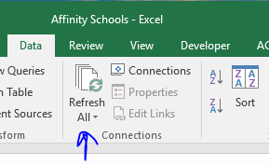
  1. You know the data is still refreshing when you see the words ‘Running background query’ in the bottom left of the workbook. The data is done refreshing when the message disappears (see image below).
* 
  1. Left-click on a value inside the pivot table in ‘Affinity School Service Summary’. Navigate to the ‘Analyze’ tab in the Microsoft Excel Ribbon, and click on ‘Refresh All’ (see image below).
* 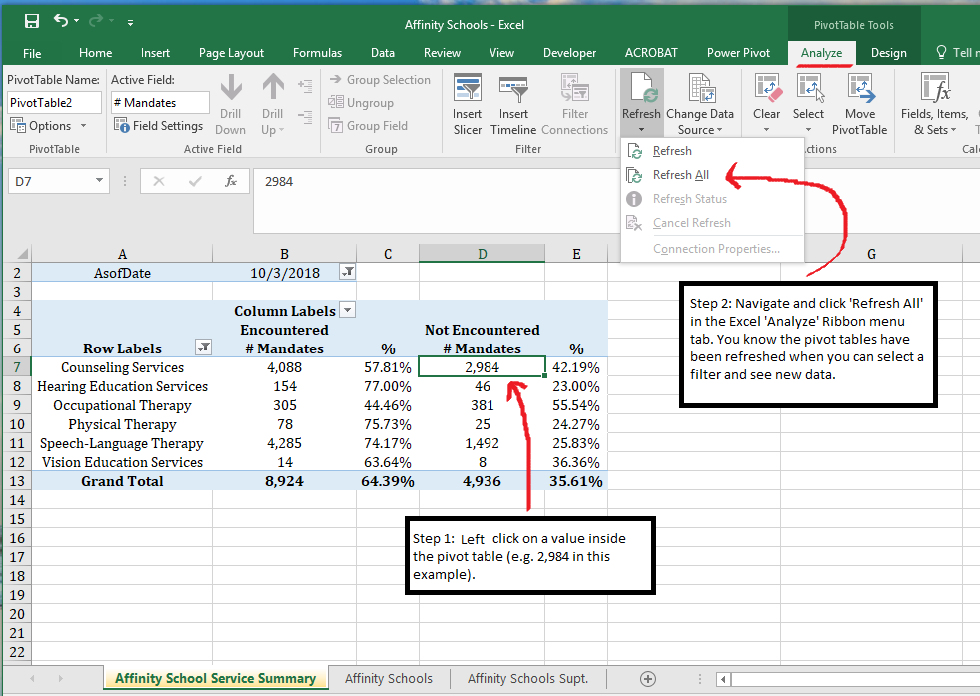
  1. In the ‘Affinity School Services Summary’ tab, **select** the most recent date in the pivot ‘AsOfDate’ filter.
  2. Go through the rest of the tabs in the Excel workbook and review each data chart. **For each data chart** **make sure that they all have their data labels**. If the data labels are missing, do the following in order for each chart (see below example):
     + Left-click on the chart itself (preferably the white space).
     + Navigate to the Microsoft Excel Ribbon ‘Design’ tab.
     + Navigate to ‘Add Chart Element’, ‘Data Labels’, and then ‘Outside End’.
* 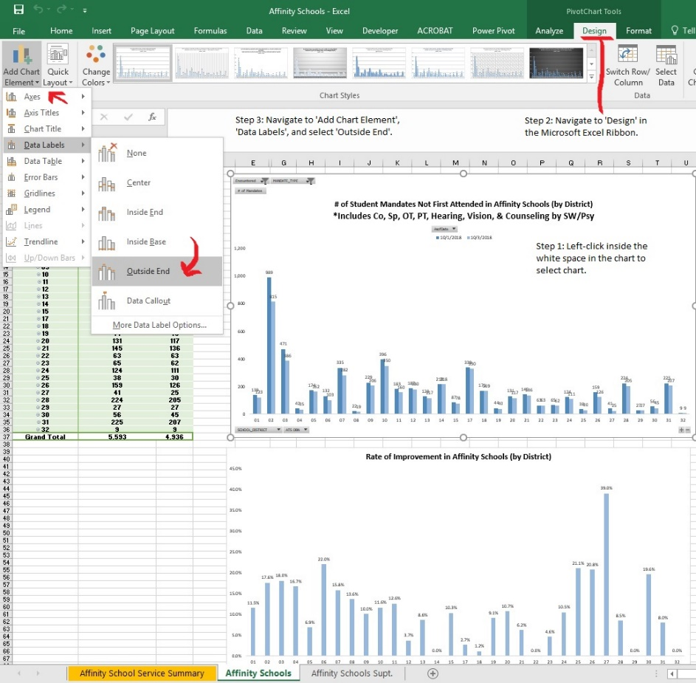
  1. **Save the Excel workbook and close it.**
  2. Repeat all aforementioned steps for all other FSC Excel files in the R drive directory (e.g. Brooklyn North, Brooklyn South, etc.) as well as the D75 file.

1. Update the ***Citywide*** File.
   1. Open the first Excel file, located in the RS directory.
   2. Click ***“Enable Content”*** if a there is a yellow privacy ribbon located at the top of the page.
   3. Navigate to the ‘**Data’** tab and click **“Refresh All” once.**
   4. Navigate to the ‘**Analyze**’ tab and click ‘Refresh All’ once.
   5. Highlight the enter table with percentages, and Right-Click to select ‘Copy’.

* 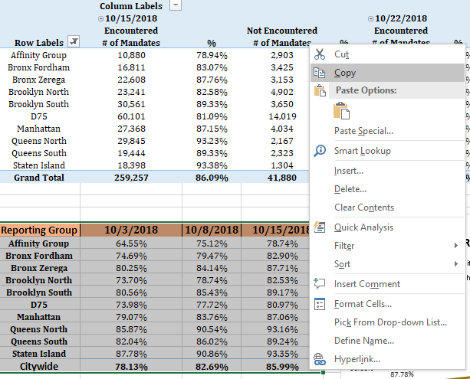
  1. Left-click on the ‘+’ sign in the workbook to create a new worksheet.
* 
  1. In the new worksheet, Left-Click on cell A1, and then Right-Click and select ‘Paste’ to copy the data. Double-left-click between the column names to ensure the values are viewable.
  2. In the Citywide Summary tab, highlight and copy G6 to G17.
  3. Paste the values to Column E in the new sheet you created before.
  4. Change E1 to reflect the latest date in the data.
  5. Left-Click on the column with the oldest data (Column B). Right-Click, and select ‘Delete’ to remove the column with the oldest data.
* 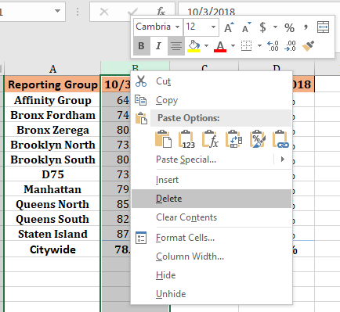
  1. Highlight the updated table in the new sheet, and paste it to the old table in the ‘Citywide Summary’ tab.
  2. Right-Click on the new worksheet you created, and ‘Delete’ it.
* 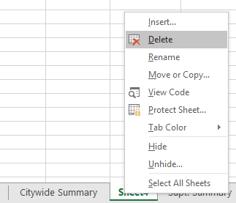
  1. **Save. Close.**

***Section 2: Make copies of the reports you refreshed into the archive folder you create***

1. **Make a new folder with the current date** in here: R:\SEO Analytics\Reporting\RS Dashboard\Weekly RS Dashboard Archive

* 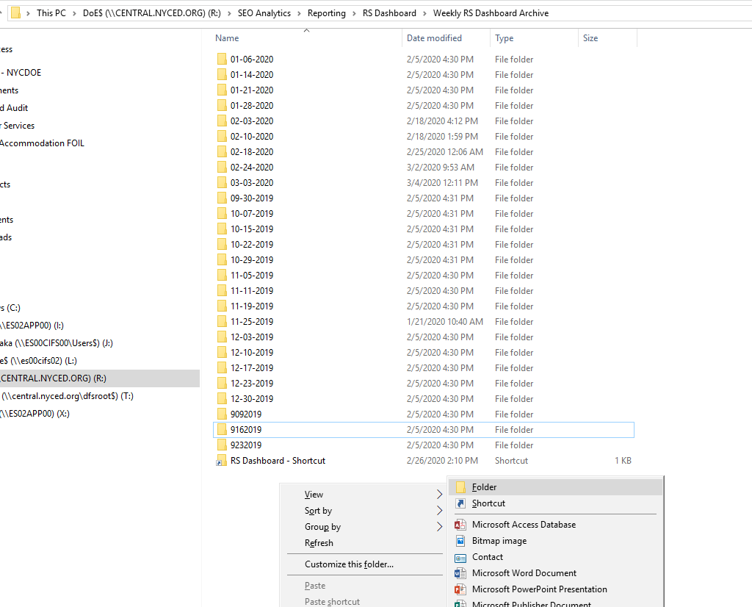
* **Rename New folder to current date**
* 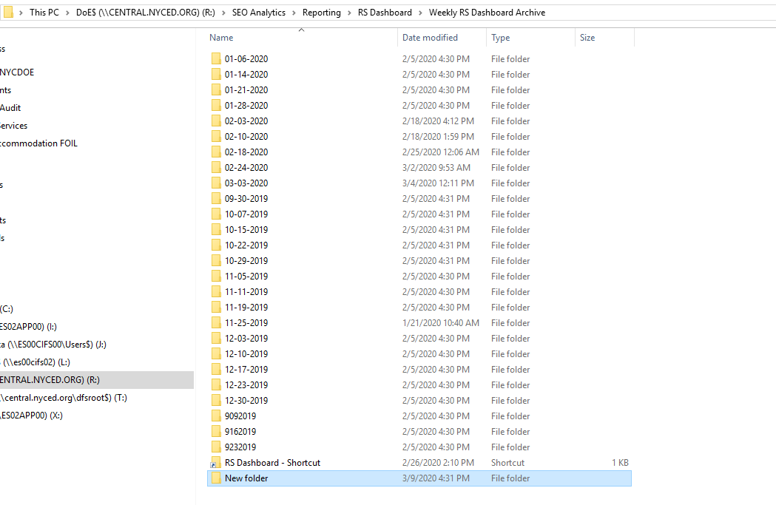

1. Make copies of every Excel report that you refreshed that day into the new folder by doing the following in order (as seen below):

* Navigate back to the main directory containing the Excel workbooks.
* Left-click on the first Excel report (Affinity).
* Hold the ‘Shift’ key and press the downward arrow key on your keyboard until all of the Excel workbooks are selected.
* Right click inside the highlighted blue area and select ‘Copy’.
* Navigate to the archive folder you created in the Section 2 (Step 1).
* Right click inside the whitespace, and click ‘Paste’.
* 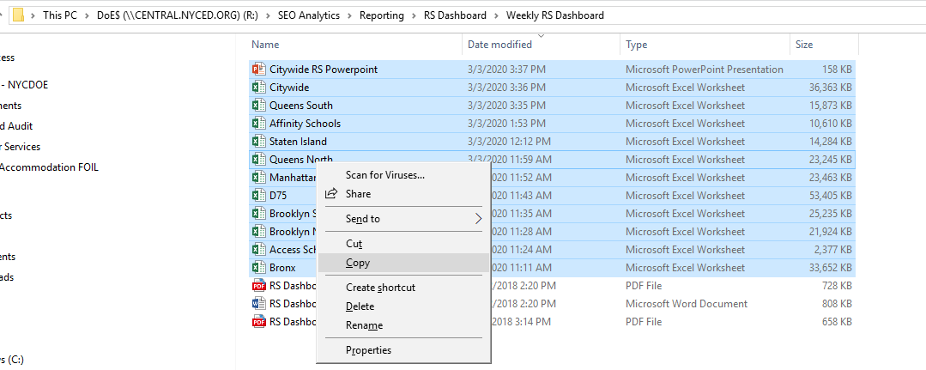
* 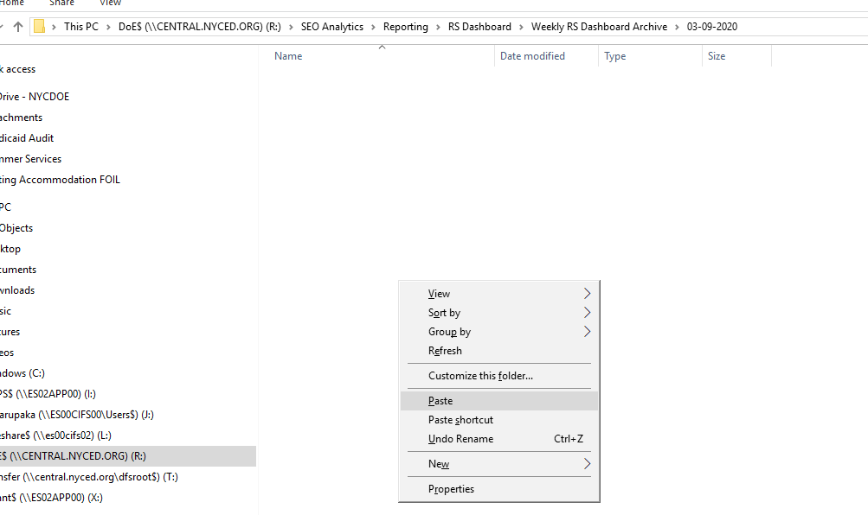

***Section 3: Publish to SharePoint***

1. Upload each of the archived Excel workbooks to SharePoint by doing the following in order.
   1. Navigate to the [SharePoint](https://nycdoe.sharepoint.com/sites/RelatedServicesDashboard) website.
   2. Click on the **Upload** button.
   3. Click the **Browse** button, then navigate back to the **FSC RS Dashboard** directory located here: R:\SEO Analytics\Reporting\RS Dashboard\Weekly RS Dashboard Archive
   4. Select the Excel report you want to upload and click **OK.**
   5. Repeat steps for all of the excel files.

**RS Dash board reports communication**

TO: Boone Cynthia <CBoone@schools.nyc.gov>; Butts Karimah <KButts@schools.nyc.gov>; Danker Jared <JDanker@schools.nyc.gov>; Epstein Susan <SEpstein5@schools.nyc.gov>; Foti Christina <CFoti@schools.nyc.gov>; Gardner Sean <SGardner@schools.nyc.gov>; George Monica <MGeorge@schools.nyc.gov>; Gold Seth <SGold6@schools.nyc.gov>; Hammer John <JHammer4@schools.nyc.gov>; Karty Alison <AKarty@schools.nyc.gov>; Kaufman Helen <HKaufma@schools.nyc.gov>; Khan Ali <AliK1@schools.nyc.gov>; Mayilrajan Rajamanickam <RMayilrajan@schools.nyc.gov>; Ramones Kimberly <KRamones@schools.nyc.gov>; Louissaint Ketler <KLouiss@schools.nyc.gov>; Marupaka Phani Bhushan <PMarupaka@schools.nyc.gov>; Miller Abby <AMiller14@schools.nyc.gov>; Navarrete Cristina <CNavarrete@schools.nyc.gov>; Capofari Nicholas <NCapofari@schools.nyc.gov>; Nutter Grace <GNutter@schools.nyc.gov>; 'Pisacano Mary Jo' <disabled.MPisaca@schools.nyc.gov>; Ramirez William <WRamirez@schools.nyc.gov>; 'Rello-Anselmi Corinne' <disabled.CRello@schools.nyc.gov>; Rodriguez Luisa <LRodriguez133@schools.nyc.gov>; Rupnarain Bebi <BRupnar@schools.nyc.gov>; Sanchez Suzanne <SSanchez8@schools.nyc.gov>; 'Scariano Nicole' <disabled.NScariano3@schools.nyc.gov>; Stamm Charles <CStamm@schools.nyc.gov>; Torres Angela <ATorres21@schools.nyc.gov>; Leong Melanie <MLeong@schools.nyc.gov>; Van Biema Michael <MVanBiema@schools.nyc.gov>; Wedderburn Simpson Barbara <BWedder@schools.nyc.gov>; Young Darnell <DYoung10@schools.nyc.gov>; Johnson Daly Veronica <VJohnsonDaly@schools.nyc.gov>; Edwards Ebony <EEdwards2@schools.nyc.gov>; Inzerelli Antonietta <AInzerelli@schools.nyc.gov>; Kostel Matt (750000) <MKostel@schools.nyc.gov>; Campos Yesenia <YCampos3@schools.nyc.gov>; Perez Jerry <JPerez42@schools.nyc.gov>; Fenice Melissa <MFenice@schools.nyc.gov>; Monaco Emma <EMonaco@schools.nyc.gov>; Mandel Betsy <BMandel6@schools.nyc.gov>; Powers Alan <APowers3@schools.nyc.gov>; Kessler Rizzo Jessica <JKessler6@schools.nyc.gov>; Fabel Suzanne <SFabel@schools.nyc.gov>; Krayets Alexandra <AKrayets@schools.nyc.gov>; Reese Stephen <SReese2@schools.nyc.gov>; Rubino Charles <CRubino3@schools.nyc.gov>; Ben-Moshe Yael <YBen-Moshe@schools.nyc.gov>; Dickar Maryann <MDickar2@schools.nyc.gov>; Lin Lisa <CLin2@schools.nyc.gov>@schools.nyc.gov>; Young Darnell <DYoung10@schools.nyc.gov>

**Subject:** RS Dashboard and RS Compliance Report mm-dd-yyyy

Hello everyone,

The Related Services Dashboard and RS Compliance Report have been updated and saved in the following sharepoint path: [https://nycdoe.sharepoint.com/sites/RelatedServicesDashboard](https://nam01.safelinks.protection.outlook.com/?url=https%3A%2F%2Fnycdoe.sharepoint.com%2Fsites%2FRelatedServicesDashboard&data=02%7C01%7CAKim14%40schools.nyc.gov%7Ce266cba97df14a2e6ba508d8543b0248%7C18492cb7ef45456185710c42e5f7ac07%7C0%7C0%7C637351959704364011&sdata=KUMxjQaGhCGaN%2BqzK65gj9mySek4HxMy0pD9c%2BBqFTY%3D&reserved=0)

*In order to use all features including drilling to student level data, you must download a local copy of this file by clicking File-->Save As-->Download a copy.

Please let me know if you have any questions/concerns.

Thank you,

Andrea

Revised: 03/09/2020

**Weekly Mandated Services Reporting Manual (SEO-MART)**

The source of data is from SQL Severs

Server: ES11VSESSQL06,31433; database: SEO_MART; tables: “RPT_RSProvisioning” and “RPT_Locations”

You must set up the ODBC and name it as “SEO_MART” before running excel RS reports for the SharePoint excel files.

Database Location:

R:\SEO Analytics\Processing\Data Mart Files\Mandate_Distribution_09_01_2020

Note: Check the field of “ProcessedDate” in the table of RPT_RSProvisioning and see if it’s up to date.

If not, this table must be refreshed before running the following steps.

**CSD Schools Mandated Services reports**

1. Mandate Services PDF files
   1. Delete previous week XLS and PDF files

* Location: R:\All Central Offices\Special Ed Data\PA_Distribution_PDF
* R:\All Central Offices\Special Ed Data\PA_Distribution_XLS
  1. Copy **Mandate_Distribution_v19.6** (Microsoft Access Database in following location) for generating PDF files for CSD Schools to local C drive
* Location: R:\SEO Analytics\Processing\Data Mart Files\Mandate_Distribution_09_05_2019
  1. Open **Mandate_Distribution_v19.6** andprovide Path as shown in below screenshot for PDF and XLS (DOE and Charter), populate PDF files on local C drive.
* 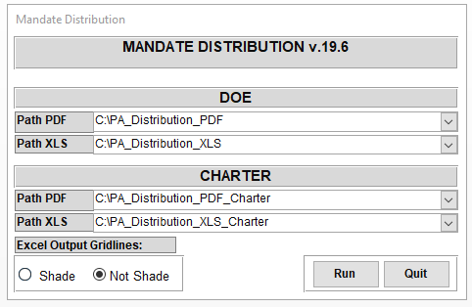
  1. Click the button name "Run"
  2. Copy around 1598 PDF files from C:\PA_Distribution_PDF to R:\All Central Offices\Special Ed Data\PA_Distribution_PDF

1. Mandate Services XLS files
   1. Copy **RS_Reports_2020_2021** (R file in following location) for generating XLS files for CSD Schools to local C drive

* Location: R:\SEO Analytics\Processing\Data Mart Files\Mandate_Distribution_09_01_2020
  1. Copy following template XLSX files to local machine C:/Template/

1. R:\SEO Analytics\Processing\Data Mart Files\Mandate_Distribution_09_01_2020\RS_Compliance_new.xlsx
2. R:\SEO Analytics\Processing\Data Mart Files\Mandate_Distribution_09_01_2020\ RS_Template_new.xlsx
   1. Open RS_Reports_2020_2021 R program on local machine
   2. Select the R code (ctrl+A)
   3. Click the button name "Run"

* 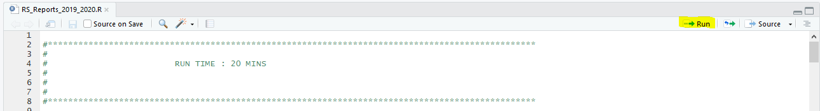
  1. Copy around 1598 XLS files in folder MandatedServices_CurrentDate (Current date. i.e. Current date is 09_March-2020 then folder name would be MandatedServices_20200309 ) to R:\All Central Offices\Special Ed Data\PA_Distribution_XLS

MandatedServices XLS files Location : R:\SEO Analytics\Reporting\Related Services\Output Files\SY 20-21

**Mandated Services Archive**

1. Create a folder with current date Backup_YYYY-MM-DD (If current date is 21-June-2021 then folder name would Backup_2012-06-21) In following location

* Location : R:\SEO Analytics\Processing\Data Mart Files\Archives

1. Copy PA_Distribution_PDF, PA_Distribution_XLS folders from R:\All Central Offices\Special Ed Data to R:\SEO Analytics\Processing\Data Mart Files\Archives\Backup_2012-06-21

**Charter Schools Mandated Services reports**

1. **Mandate Services PDF files**
   1. Copy **Mandate_Distribution_Charter_v19.6** (Microsoft Access Database in following location) for generating PDF files for Charter Schools to local C drive

* Location: R:\SEO Analytics\Processing\Data Mart Files\Mandate_Distribution_09_01_2020
  1. Open **Mandate_Distribution_Charter_v19.6** and provide Path as shown in below screenshot for PDF and XLS (DOE and Charter), populate PDF files on local C drive.
* 
  1. Click the button name "Run"
  2. Create a folder with YYYYMMDD (If current date is 21-June-2021 then folder name would 20210621)
* In following location Location : R:\SEO Analytics\Share\Charter\20210621
  1. Copy folder from C:\PA_Distribution_PDF_Charter to R:\SEO Analytics\Share\Charter\20210621

1. **Mandate Services XLS files**
   1. Copy **RS_Reports_2021_2021_Charter** (R file in following location) for generating XLS files for Charter Schools to local C drive

* Location: R:\SEO Analytics\Processing\Data Mart Files\Mandate_Distribution_09_01_2020
  1. Copy following template XLSX files to local machine C:/Template/

1. R:\SEO Analytics\Processing\Data Mart Files\Mandate_Distribution_09_01_2020\ RS_Compliance_new.xlsx

ii. R:\SEO Analytics\Processing\Data Mart Files\Mandate_Distribution_09_01_2021\ RS_Template_new.xlsx

* 1. Open RS_Reports_2020_2021_Charter R program on local machine
  2. Select the R code (ctrl+A)
  3. Click the button name "Run"
* 
  1. Copy around 268 XLS files folder from following following MandatedServicesCharter_CurrentDate location (Current date. i.e. Current date is 21_June-2021 then folder name would be MandatedServicesCharter_20210621 ) to [R:\SEO Analytics\Share\Charter\20210621](file:///R:/All%20Central%20Offices/Special%20Ed%20Data/PA_Distribution_PDF)

MandatedServicesCharter XLS files Location : R:\SEO Analytics\Reporting\Related Services\Output Files\SY 20-21 Charter\MandatedServicesCharter_20210621

**Mandated Services Charter Archive**

1. Create a folder with current date YYYYMMDD (If current date is 09-March-2020 then folder name would 20200309) In following location

* Location : R:\SEO Analytics\Reporting\CharterArchive

1. Copy PA_Distribution_PDF_Charter, PA_Distribution_XLS_Charter folders from R:\SEO Analytics\Share\Charter\20210609 to R:\SEO Analytics\Reporting\CharterArchive\20210621

**Charter Schools Mandated Services communication**

**Send an email to following recipients**

**Email Subject : Weekly Charter Related Services Report 06/21/2021**

**To :** Van Biema Michael <MVanBiema@schools.nyc.gov>; Delane Gurley Mia <MGurley@schools.nyc.gov>; Liu Mei <MLiu2@schools.nyc.gov>; Thompson Karyn <KThompson7@schools.nyc.gov>; Sandi Mariama <MSandi@schools.nyc.gov>; Rowe Janyce <JRowe@schools.nyc.gov>; Gold Seth <SGold6@schools.nyc.gov>; Stamm Charles <CStamm@schools.nyc.gov>; Hinds Harold [HHinds@schools.nyc.gov](mailto:HHinds@schools.nyc.gov)

**CC :** Mayilrajan Rajamanickam <RMayilrajan@schools.nyc.gov>; Strickland Scott <SStrickland4@schools.nyc.gov>; Fisher Gabrielle <GFisher3@schools.nyc.gov>; Leibowitz Matthew <MLeibow@schools.nyc.gov>; Nutter Grace <GNutter@schools.nyc.gov>; Joshi Bhavinkumar <BJoshi@schools.nyc.gov>; Liu Qun David <QLiu@schools.nyc.gov>; Liu Mei <MLiu2@schools.nyc.gov>; Kamdar Neepa <NKamdar@schools.nyc.gov>; Gadam Gouri Sandeep <GGadam@schools.nyc.gov>; Cummings Kisha <KCummings5@schools.nyc.gov>; Nooning K'lila <KNooning@schools.nyc.gov>; Wu Simon <SWu10@schools.nyc.gov>; Marupaka Phani Bhushan <PMarupaka@schools.nyc.gov>; Danker Jared <JDanker@schools.nyc.gov>; Rodriguez Luisa <LRodriguez133@schools.nyc.gov>; Powers Alan <APowers3@schools.nyc.gov>; Edwards Ebony <EEdwards2@schools.nyc.gov>

**Email**

Hi Everyone,

I hope this email finds you well.

Please find the weekly charter Related Service reports in the following folder:

**Charter School Reports (PDF and XLS files)**

R:\SEO Analytics\Share\Charter\20210614

Thank you and please let me know if you have any questions/concerns.

Andrea

Revised: 03/09/2020

**Weekly Mandated Services Updates Manual (SEO-MART)**

The source of data is from SQL Severs

Server: ES11VSESSQL06,31433; database: SEO_MART; view:“vw_RPT_MandatedServicesDistribution”

You must set up the ODBC and name it as “SEO_MART” before running excel RS reports for the SharePoint excel files.

**Mandated Services updates**

* + - 1. Update SharePoint Files
  1. Create a new folder with the name as today's date in directory below.
* R:\SEO Analytics\Processing\Data Mart Files\Weekly Excel Reports\yyyy-mm-dd
  1. Copy excel template files from below directory **(Source) -- Please don't change this one**
* R:\SEO Analytics\Processing\Data Mart Files\Templates\SESIS Mandated Services Report\
* Paste to this directory **(target directory)**
* R:\SEO Analytics\Processing\Data Mart Files\Weekly Excel Reports\yyyy-mm-dd
* Change the suffix of the excel file name (in target directory) to today's date
* Example, “SESIS……….as of **mm-dd-yyyy.xlsx**”
  1. Open all **spreadsheets** one by one and perform the following tasks within the **target directory** as showed above.
     1. Click “Refresh All” under "DATA" from the menu bar.
     2. Click “Refresh” again under "DATA" from the menu bar.
        1. The “As Of Date” should change to reflect to the date you process the file.
     3. Delete the "Raw Data" tab in the workbook.
     4. Save it.

*Repeat to do all excel files within the target directory

1. Replace old files in SharePoint directory below
   * 1. Delete all files in here R:\All Central Offices\Special Ed Data\PA SharePoint
     2. Copy all files from "**Target directory**"

* R:\SEO Analytics\Processing\Data Mart Files\Weekly Excel Reports\yyyy-mm-dd
  + 1. Paste to R:\All Central Offices\Special Ed Data\PA SharePoint
  1. Upload excel files to SharePoint
* (email “Nicolette Strachan” to upload the file if you can’t access to the SharePoint) SharePoint Location:
* <http://portal.nycboe.net/sites/EducationPolicy/specialpopulations/Related%20Services%20Compliance%20Tracking%20Reports/Forms/AllItems.aspx?RootFolder=%2fsites%2fEducationPolicy%2fspecialpopulations%2fRelated%20Services%20Compliance%20Tracking%20Reports%2fSESIS%20Mandates%20for%20Assignment&FolderCTID=&View=%7b92E29764%2dB24D%2d4A1C%2dB3AB%2dADB23A6E6B9F%7d>

**Mandated Services updates communication**

**To:** Van Biema Michael <MVanBiema@schools.nyc.gov>; Palladino Linette <LPalladino2@schools.nyc.gov>; Morgenstern Josh <JMorgenstern@schools.nyc.gov>; Kaufman Helen <HKaufma@schools.nyc.gov>; 'Leo Maria' <MLeo2@schools.nyc.gov>; Elkayam Barry <BElkaya@schools.nyc.gov>; Shah Archana <AShah@schools.nyc.gov>; Stamm Charles <CStamm@schools.nyc.gov>; Leong Melanie <MLeong@schools.nyc.gov>; Han Louise <LHan@schools.nyc.gov>; Silverman Joy <JSilverman8@schools.nyc.gov>

**Cc:** **Mayilrajan Rajamanickam <RMayilrajan@schools.nyc.gov>; Danker Jared <JDanker@schools.nyc.gov>; Marupaka Phani Bhushan <PMarupaka@schools.nyc.gov>; Cummings Kisha <KCummings5@schools.nyc.gov>; Nutter Grace <GNutter@schools.nyc.gov>; Rodriguez Luisa <LRodriguez133@schools.nyc.gov>; Edwards Ebony <EEdwards2@schools.nyc.gov>; Powers Alan <APowers3@schools.nyc.gov>**

**Subject:** Mandated Services updates for mm-dd-yyyy

Hello All,

Updates at the Borough/City wide office (BCO) level have been updated to R:\Drive (R:\All Central Offices\Special Ed Data\PA SharePoint) and posted to [SharePoint.](https://nam10.safelinks.protection.outlook.com/?url=https%3A%2F%2Fnycdoe.sharepoint.com%2F%3Af%3A%2Fr%2Fsites%2Fseo%2FShared%2520Documents%2FMandated%2520Services%2520updates%3Fcsf%3D1%26web%3D1%26e%3DD2JRDb&data=04%7C01%7CAKim14%40schools.nyc.gov%7Cda2956c8426a41554b9108d91eeaeddc%7C18492cb7ef45456185710c42e5f7ac07%7C0%7C0%7C637574816628440711%7CUnknown%7CTWFpbGZsb3d8eyJWIjoiMC4wLjAwMDAiLCJQIjoiV2luMzIiLCJBTiI6Ik1haWwiLCJXVCI6Mn0%3D%7C1000&sdata=X0%2BNlxXKidy20Z6U7soXkfAdhTRIb5F18sHdGaRS2Ao%3D&reserved=0)

The above link is for sharing student level data.  If you are denied access, please log out of the network and then log back in.

* Please do not modify or store any personal files within any of our directories.

We use that drive as a staging area to load and distribute student level data to various systems/people within the DOE.

Thank you,

Andrea

# Addendum

RS RAD Data

For the 20-21 school year, RAD document data in SESIS have been organized into SEO MART to support blended/remote learning reporting. RAD data is at the mandate level and therefore is not a student level information (ex: a student may have multiple services, and each service will require a RAD document)

Table: INT_RADRSProfiles

|  |  |  |
| --- | --- | --- |
| Column Name | Business Rules | Notes |
| RSRADStatus | case when DocStatus = 1 then 'In Draft'  when DocStatus = 3 then 'Finalized'  when DocStatus = 2 then 'In Review'  when DocStatus is null then 'Not Started' END |  |
| TotalRADAttempts | Count of DWH_RSPADProfiles table (DateTimeFirstAttempt,DateTimeSecondAttempt… DateTimeEighthAttempt) | How many attempts were made by DOE to contact parent |
| IsRADAttemptSuccessful | CASE WHEN isFirstAttemptSuccessful=1 OR isSecondAttemptSuccessful=1 OR isThirdAttemptSuccessful=1 OR isFourthAttemptSuccessful=1 OR  IsFifthAttemptSuccessful=1 OR isSixthAttemptSuccessul=1 OR isSeventhAttemptSuccesful=1 OR isEighthAttemptSuccesful=1  THEN 1  ELSE 0 END |  |
| RADPrintDate | Column is populated from DWH_SECAuditLog table based StudentID, DocumentIDT. Column   EventDatetime will be RADPrintDate,  we get the first print event. | Following query will give you RS print documents  (DWH_SECAuditLog table name will be DWH_AuditLogDocPrint):  Select * from DWH_SECAuditLog where EventSubobjectCategoryIDT=573 |
| MatchKey |  | Column is populated from INT_RelatedServices table based on StudentID, LatestConfDocIDT, ServiceType, GroupType ,RADMandateLanguage. |

# Document Control

## Revision History

A softcopy of the most current version of this document can be found at the following address:

[*https://nycdoe.sharepoint.com/sites/SEODMReportingTeam/Shared%20Documents/Forms/AllItems.aspx?viewid=a03b1e09%2D3c9b%2D4fa5%2Db4d2%2De6b07dd59d05&id=%2Fsites%2FSEODMReportingTeam%2FShared%20Documents%2FTechnical%20Documentation%2FRelated%20Services*](https://nycdoe.sharepoint.com/sites/SEODMReportingTeam/Shared%20Documents/Forms/AllItems.aspx?viewid=a03b1e09%2D3c9b%2D4fa5%2Db4d2%2De6b07dd59d05&id=%2Fsites%2FSEODMReportingTeam%2FShared%20Documents%2FTechnical%20Documentation%2FRelated%20Services)

| Version | Date | Status | Description | Author |
| --- | --- | --- | --- | --- |
| 0.1 | April 5, 2019 | Draft | Based on   * CC Design Sprint, week of April 1, 2019 | Grace Nutter |
| 0.2 | June 24, 2021 | Draft | Summer Rollover planning | Andrea Kim |

Version 0.1 / 05 APR 2019 / Draft

## Reviewers (to date)

| Role | Name |
| --- | --- |
| Program Owner | Ebony Edwards |
| Project Lead | Andrea Kim |
| Project Manager | Kisha |
| Project Team Member (SME- DM) | Phani |
| Project Team Member (SME- Reporting) | Jared |
| QA/QC |  |

1. R:\SEO Analytics\Reporting\RS Dashboard\Weekly RS Dashboard
2. [https://nycdoe.sharepoint.com/sites/RelatedServicesDashboard](https://nam10.safelinks.protection.outlook.com/?url=https%3A%2F%2Fnycdoe.sharepoint.com%2Fsites%2FRelatedServicesDashboard&data=04%7C01%7CAKim14%40schools.nyc.gov%7C26a71b4977e84c85839f08d9300f762f%7C18492cb7ef45456185710c42e5f7ac07%7C0%7C0%7C637593665225026275%7CUnknown%7CTWFpbGZsb3d8eyJWIjoiMC4wLjAwMDAiLCJQIjoiV2luMzIiLCJBTiI6Ik1haWwiLCJXVCI6Mn0%3D%7C1000&sdata=MFowINCN6wV1UFADhjvjY3b4TVvfbRJg%2FaKHX%2BBYL0c%3D&reserved=0)